|  |
| --- |
| **L&T Technology Services** |
|  |
| Site Manager Auditing & Reporting Tool (SMART)  **Software Design Document**  1.0 |
|  |
| V4.0 |

|  |  |  |  |
| --- | --- | --- | --- |
| **Approver Name** | **Title** | **Signature** | **Date** |
| Arun Ravindranath | Program Manager |  | 09/05/2019 |

**RECORD OF RELEASE**

| **Ver. Rel. No** | **Release Date** | **Modified By**  **Modification date** | **Reviewed By Relevant Stake Holders**  **Reviewed Date** | **Authorized By Authorization Date** | **Remarks/Revision Details** |
| --- | --- | --- | --- | --- | --- |
| V1.0 | 18/01/2019 | L&T Team | L&T Team | Arun Ravindranath | 1st version of SDD |
|  |  | 18/01/2019 | 18/01/2019 | 18/01/2019 |  |
| V2.0 | 08/03/2019 | L&T Team | L&T Team | Arun Ravindranath | 2nd version of SDD |
|  |  | 08/03/2019 | 08/03/2019 | 08/03/2019 |  |
| V3.0 | 29/03/2019 | L&T Team | L&T Team | Arun Ravindranath | 3rd version of SDD |
|  |  | 29/03/2019 | 29/03/2019 | 29/03/2019 |  |
| V4.0 | 09/05/2019 | L&T Team | L&T Team | Arun Ravindranath | 4th version of SDD |
|  |  | 09/05/2019 | 09/05/2019 | 09/05/2019 |  |
| Summary of Changes: NA | | | | | |

Table of Contents

1.0 INTRODUCTION 6

1.1 Scope and overview 6

1.2 Assumptions, Constraints & Limitations 6

1.3 References 6

1.4 Acronyms and Abbreviations 6

2.0 System Overview 7

2.1 System architecture 7

3.0 Development/Test Environment 8

3.1 Development Environment 8

3.2 Test Environment 8

4.0 Design 8

4.1 Dashboard 8

4.2 Privileges 10

4.3 Configurations 10

4.3.1 User management 10

4.3.2 N/W Config 12

4.3.3 General Config 14

4.3.4 Audit Trail 18

4.4 Rules 19

4.5 Pre-Migration 29

4.5.1 Block diagram 30

4.6 Migration 43

4.6.1 Block diagram 44

4.7 Post Migration 50

4.7.1 Block diagram 50

4.8 S & R 60

4.8.1 Scheduling: 60

4.8.2 Overall Reports 62

4.8.3 Reports 64

Table of Figures

Figure 1: System Architecture 7

Figure 2: Dashboard: C&I Details 9

Figure 3: Dashboard: Smart Health Tool 9

Figure 4: Configurations: User Management 10

Figure 5: User Management: Creation 11

Figure 6: Configurations: Network Config: Search 12

Figure 7: Configurations: Network Config: Create New 13

Figure 8: Configurations: General Config - NW Type 14

Figure 9: Configurations: General Config - Customer 15

Figure 10: Configurations: General Config - Customer: Create New 16

Figure 11: Configurations: General Config – NE Version 17

Figure 12: Configurations: General Config - Configuration – General Settings 18

Figure 13: Configurations - Audit Trial 18

Figure 14: Rules – Script Store: Upload Command 19

Figure 15: Rules – Script Store: Search 20

Figure 16: Rules -Command Rule Builder: Create 22

Figure 17: Rules - Command Rule Builder: Search 23

Figure 18: Rules: File Builder – Create 25

Figure 19: Rules: File Builder – Search 25

Figure 20: Rules: Use Case Builder – Create 27

Figure 21: Rules: Use Case Builder – Search 28

Figure 22: Block Diagram for Pre-Migration 30

Figure 23: Pre-Migration: Retrieve CIQ - Upload 31

Figure 24: Pre-Migration: Retrieve CIQ - Fetch 32

Figure 25: Pre-Migration: Retrieve CIQ - Search 33

Figure 26: Pre-Migration: Checklist 34

Figure 27: Pre-Migration: NE Mapping 34

Figure 28: Pre-Migration: Ran-Config - CIQ 35

Figure 29: Pre-Migration: Ran-Config – NE’s 37

Figure 30: Pre-Migration: Ran-Config – NE’s - Edit 38

Figure 31: Pre-Migration: Generate 39

Figure 32: Pre-Migration: Generate: Search 40

Figure 33: Pre-Migration: NE Grow: Grow 41

Figure 34: Pre-Migration: NE Grow: Search 41

Figure 35: Pre-Migration – Report View 42

Figure 36: Pre-Migration – Script View 43

Figure 37: Block Diagram for Migration 44

Figure 38:Migration: Commission 45

Figure 39:Migration: Search 46

Figure 40:Migration: Use Case Execution Sequence 46

Figure 41: Migration: Script Execution Sequence 47

Figure 42: Migration: Script Generate 47

Figure 43: Migration: Download Log 48

Figure 44: Migration: Running Log 48

Figure 45: Migration: Check List 49

Figure 46: Migration: Check List 49

Figure 47: Block Diagram for Post Migration 50

Figure 48: Post Migration: RAN ATP 51

Figure 49: Post Migration: Download Logs 52

Figure 50: Post Migration: Running Logs 52

Figure 51: Post Migration: Check List 53

Figure 52: Post Migration: Result View 53

Figure 53: Post Migration: Xlsx downloaded 54

Figure 54: Post Migration: Xlsx report 54

Figure 55: Post Migration: Audit 55

Figure 56: Post Migration: Download logs 55

Figure 57: Post Migration: Running Log 56

Figure 58: Post Migration: Check List 56

Figure 59: Post Migration: Result View 57

Figure 60: Post Migration: html 57

Figure 61: Post Migration: html output 58

Figure 62: Post Migration - Site Data 58

Figure 63: Post Migration - Site Data - Search 59

Figure 64: Post Migration: EOD Reports 60

Figure 65: S & R: Scheduling – Verizon 61

Figure 66: S & R: Scheduling – Sprint 62

Figure 67: S & R: Overall Reports – Verizon 62

Figure 68: S & R: Overall Reports - Sprint 63

Figure 69: S & R: Reports - Daily 64

Figure 70: S & R: Reports - Weekly 64

Figure 71: S & R: Reports - Periodic 65

Table of Tables

Table 1: Assumptions / Constraints / Limitations 6

Table 2: References 6

Table 3: Acronyms and Abbreviation 6

# INTRODUCTION

## **Scope and overview**

SMART tool acts as a platform for overall commissioning of all Samsung RAN Equipment platforms (3G/4G/5G). This covers the stages such as **PRE-Migration** (CIQ), **Migration** (Loading) and **POST Migration** (Checking core health).

## **Assumptions, Constraints & Limitations**

Table 1: Assumptions / Constraints / Limitations

| **Sl. No.** | **Assumptions/Constraints/Limitations** |
| --- | --- |
| 1 | The Tool is used by commissioning engineer |
| 2 | The tool requires VPN connection and access to System Manager node for growing Network Element |
| 3 | Tool will be deployed in Samsung Lab, Samsung Datacenter |
| 4 | All CLI commands and scripts will be provided by Samsung |
| 5 | Data Retention period is 90 days |

## **References**

|  |  |  |  |  |
| --- | --- | --- | --- | --- |
| **S. No.** | **Document ID** | **Contents of the document** | **Ver./ No.** | **Remarks** |
| 1 | 330 LTE CDU30 FDD TDD D2 eNB Commissioning and Integration Manual for Release 7.1.0_v1.1 | eNB commissioning and integration process | V1.1 |  |
| 2 | C&I Tool Scope for CDU30 MIMO Commissioning | Grow eNB, migration and post checks information | NA |  |
| 3 | UNY-NE-VZ_CIQ_Ver2.58_10182018 | CIQ template file | NA |  |
| 4 | SMART- Requirement-v1.0 | Basic requirements of SMART | V1.0 |  |
| 5 | GrowTemplate_702_068785_BURLINGTON_CT10222018_10_35_23 | Sample csv file | NA |  |

Table 2: References

## **Acronyms and Abbreviations**

|  |  |
| --- | --- |
| Acronym | Abbreviation/Definition |
| SMART | Site Manager Audit, Reporting and Testing |
| CIQ | Customer Information Questionnaire |
| SM | System Manager |
| FTP | File Transfer Protocol |
| NE | Network Element |

Table 3: Acronyms and Abbreviation

# System Overview

## **System architecture**

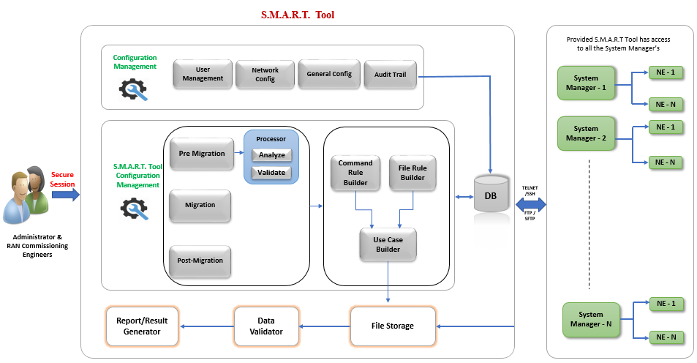

Figure 1: System Architecture

* User Management: User Creation/Deletion, Password Management, Privilege Management.
* N/W Config: It will have all the System Manager details such as LSM, Sane Server or FTP Server.
* General config: It contains 3 tabs: NW Type, Customer Creation and General Settings.
* Audit Trail: Admin can access all the events and actions of all users of the tool.
* SMART Tool is divided into three major modules:
* Pre-Migration: It is used to grow NE’s as per the input files provided.
* Migration: It is used to commission the NEs.
* Post Migration: It is used to perform health check the NE’s.
* DB: Mongo DB and Maria DB is used for Storage.
* File Storage: The script outputs will be stored in the local system and its validated.
* Report/Result Generator: The Scripts output are validated and displayed to the user.

# Development/Test Environment

## **Development Environment**

| **Entity** | **Name** | **Version** |
| --- | --- | --- |
| OS | Ubuntu | 16.x |
| Application Server | Tomcat | 8 |
| Database | MariaDB, MongoDB | MariaDB - 10.1.36, MongoDB - 3.2.21 |
| Language | Java, Angular | JDK 1.7+, Angular 6 |
| IDE | Eclipse | Luna+ |
| Building Tool | Maven | 3.x |
| Browsers | Chrome and Firefox | Chrome: 49+  Firefox: 50+  Best viewed resolution is 1280 * 1024. |

## **Test Environment**

Currently the Samsung Lab test infrastructure is considered for the Design, Development and Test. It will be revisited during the development stage.

# Design

## **Dashboard**

Dashboard contains two tabs:

1. C&I Details
2. Smart Tool Health

Dashboard contains the details such as numbers of users logged in, disk usage, memory usage, CPU usage and network elements commissioned report using SMART tool for all the customers/platforms (3G/4G/5G).

C&I Details contains below information:

* A bar graph which displays the overall commissioning report/summary of all the NE's commissioned by each customer
* A Bar graph which displays the premarket commissioning report/summary based on the customer selection

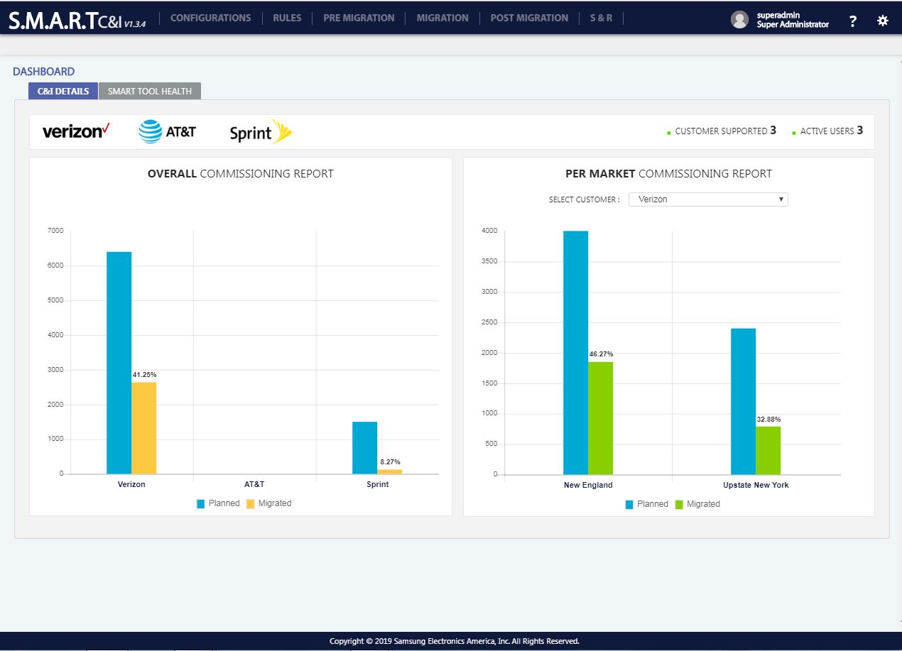

Figure 2: Dashboard: C&I Details

Smart Tool Health contains below information:

* A pie chart which displays the disk usage of the system.
* A pie chart which displays the memory usage of the system.
* Smart tool health displays the CPU usage.

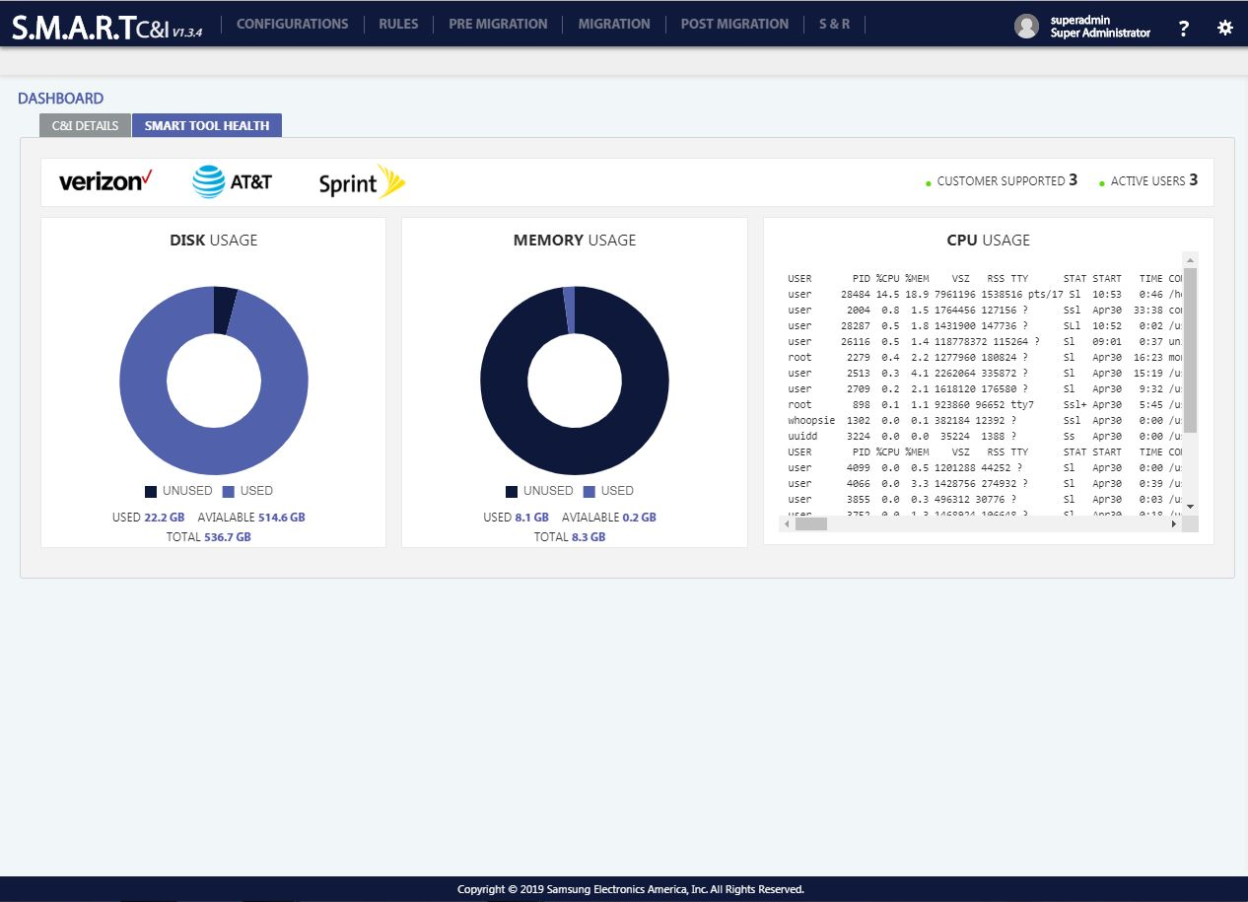

Figure 3: Dashboard: Smart Health Tool

## **Privileges**

Privileges granted to each user of the SMART Tool is given below:

|  |  |  |  |  |  |  |  |  |
| --- | --- | --- | --- | --- | --- | --- | --- | --- |
| User Role | Customer Specific | Program Name | Configurations | Rules | Pre-Migration | Migration | Post Migration | Scheduling |
| Default User | NA | NA | Yes | No | No | No | No | No |
| Super Administrator | All | All | Yes | Yes | Yes | Yes | Yes | Yes |
| Customer Administrator | Yes | Yes | Yes | Yes | Yes | Yes | Yes | Yes |
| Commission Manager | Yes | Yes | Yes | Yes | Yes | Yes | Yes | Yes |
| Commission Engineer | Yes | Yes | No | Yes | Yes | Yes | Yes | No |

## **Configurations**

Configuration Management is used to configure the SMART Application. This contains the below modules:

* User Management
* N/W Config
* General Config
* Audit Trail

### **User management**

User management allows users to create, update and delete the user. Multiple users can be created based on the access privilege. By Default, a login will be given, which can be used to create “Super Administrator”.

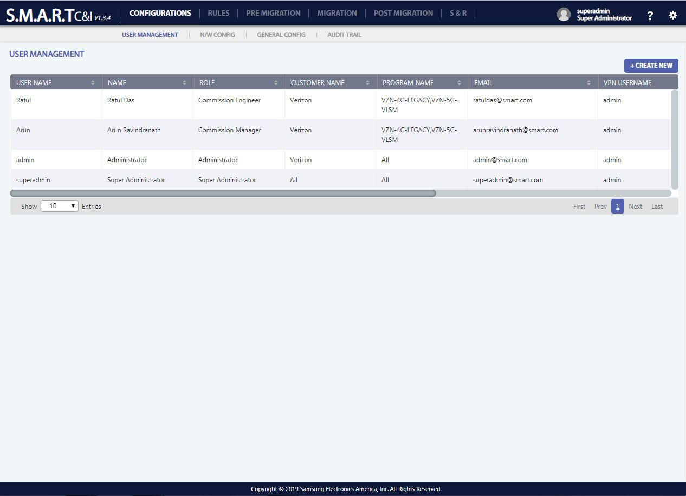

Figure 4: Configurations: User Management

1. **To add** a new user, Click on Create New Button () placed on top right position of the data table and enter the mandatory fields which are user name, name, password, confirm password, role, customer name, program name, email, VPN username and VPN password
2. **To edit** user details, click on the edit icon () appearing when roll over on a user details record. Name, password, confirm password, role, customer name, program name, email, VPN username and VPN password are editable parameters. User Name is non – editable parameter.
3. **To delete** user detail, click on the delete icon () appearing, when roll over on a user detail record. A confirmation popup with “YES/NO” options appears on click of delete icon. “YES” will delete the record and “NO” will be redirected to the previous screen.

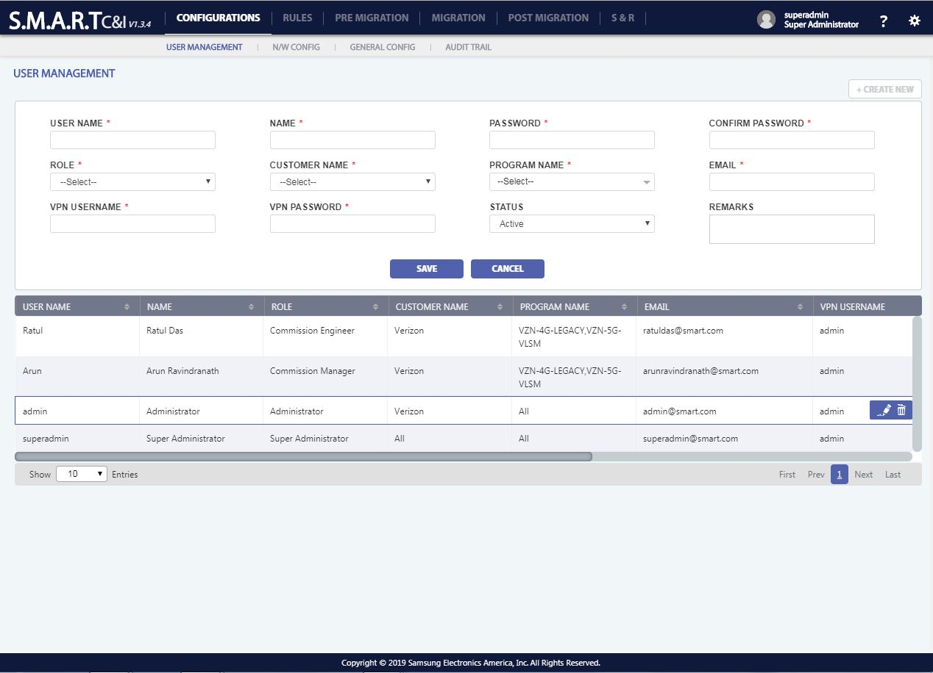

Figure 5: User Management: Creation

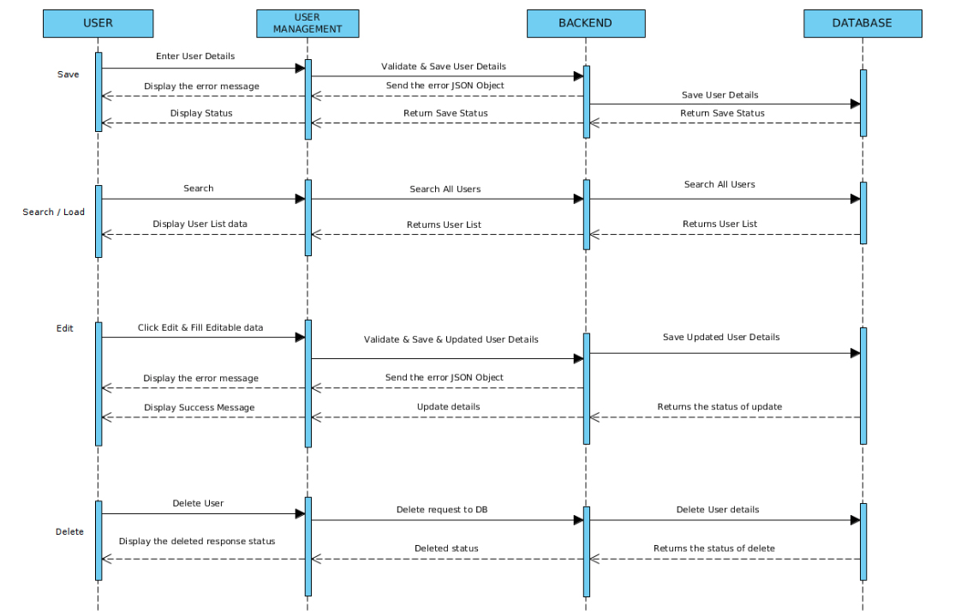

### **N/W Config**

N/W configuration can create multiple configurations with inputs such as Program Name, NE Type, NE name, NE version, IP Address, Username and Password to acquire connection with SM. User can import the details of SM present in an excel file through the ‘IMPORT’ functionality. User can export all the details of SM present in the tool through the ‘EXPORT’ functionality. Configurations can be searched based on inputs such as Program Name, NE Type, NE name, NE version, IP Address, Username.

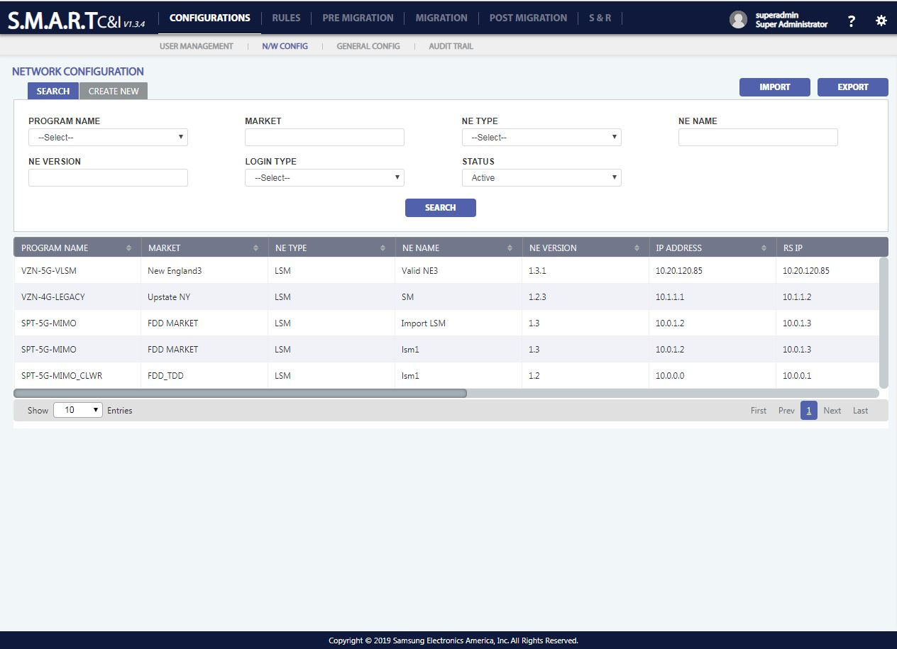

Figure 6: Configurations: Network Config: Search

1. **To search** a network configuration record, click on search Button () placed on top left position of the data table and enter the required fields to search.
2. **To add** a new network configuration, Click on Create New Button () placed on top left position of the data table and enter the mandatory fields which are user name, name, password, confirm password, role, customer name, program name, email, VPN username and VPN password
3. **To edit** user details, click on the edit icon () appearing when roll over on a user details record. Name, password, confirm password, role, customer name, program name, email, VPN username and VPN password are editable parameters. User Name is non – editable parameter.
4. **To delete** user detail, click on the delete icon () appearing, when roll over on a user detail record. A confirmation popup with “YES/NO” options appears on click of delete icon. “YES” will delete the record and “NO” will be redirected to the previous screen.
5. **To export** existing Network Configuration Details, click on export Button () placed on top right position of the data table.
6. **To import** Network Configuration Details to database, click on import Button

() placed on top right position of the data table.

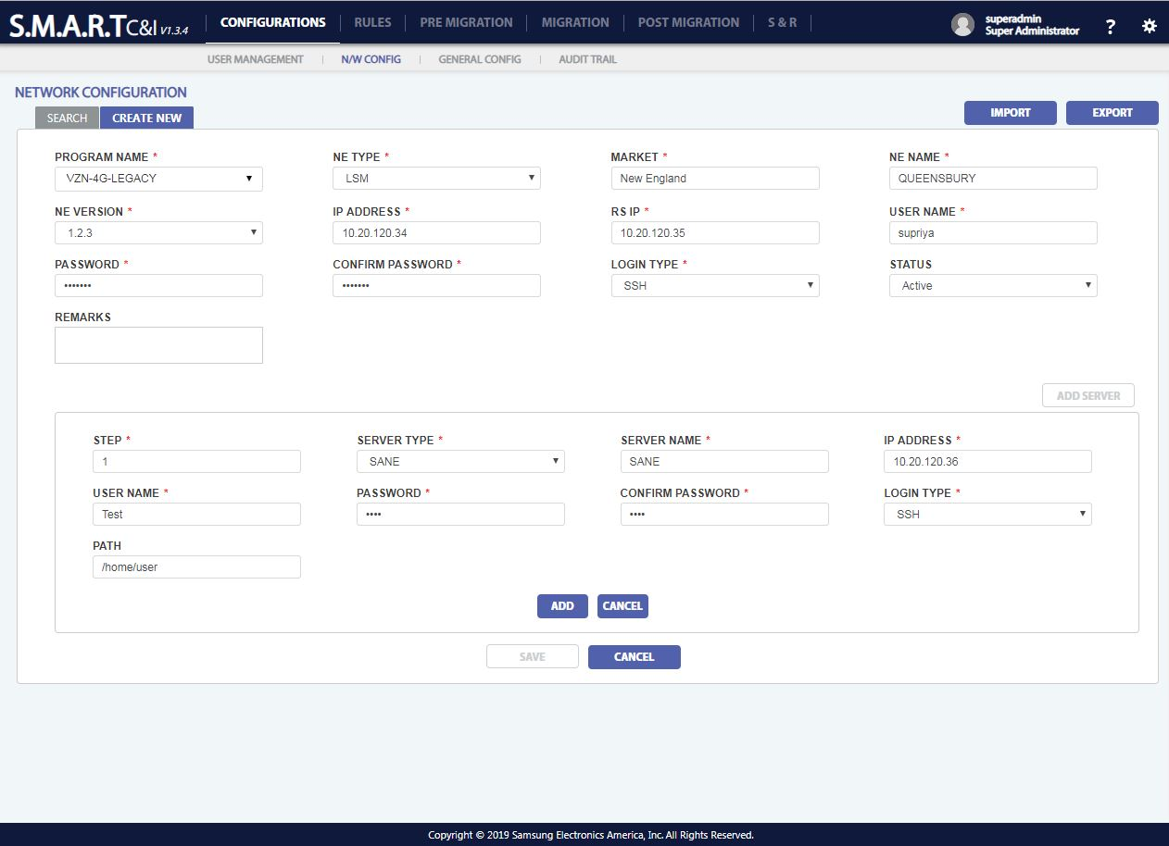

Figure 7: Configurations: Network Config: Create New

### **General Config**

General configuration contains 3 tabs: NW Type, Customer, NE Version, General Settings

#### **N/W Type**

The user can create the Network(N/W) Type for its customers.

1. **To add** a new network type, click on add Button () placed on top right position of the data table.

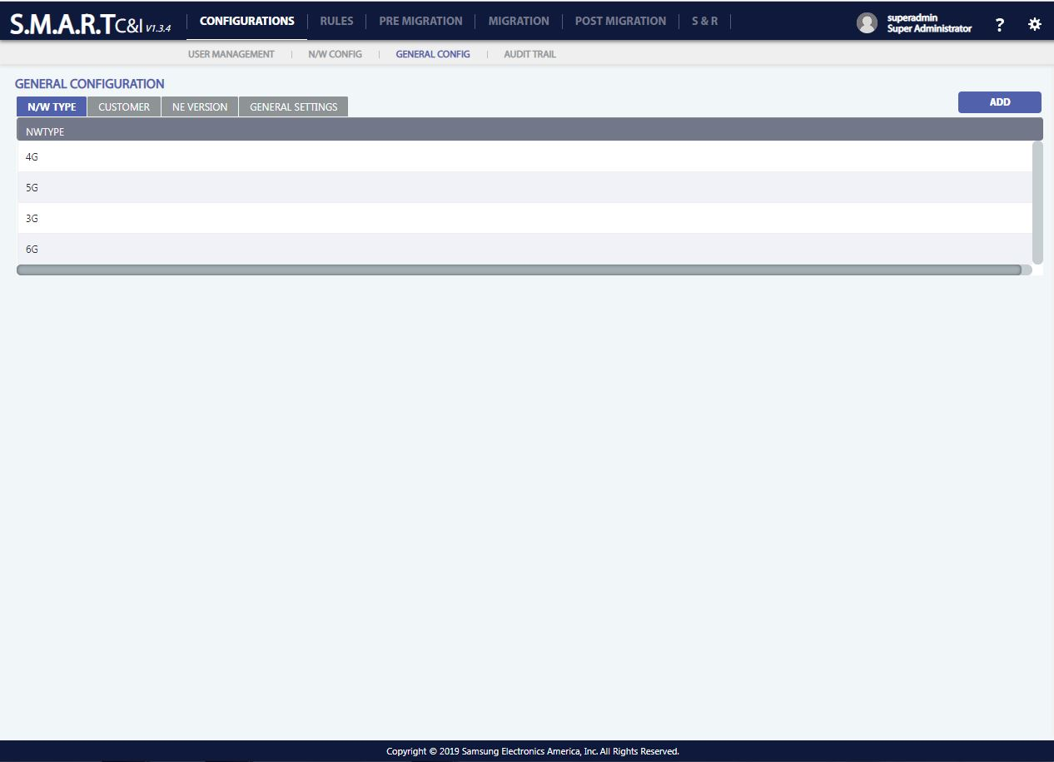

Figure 8: Configurations: General Config - NW Type

#### **Customer**

The user can create a new customer or modify the existing customer based on Program Name.

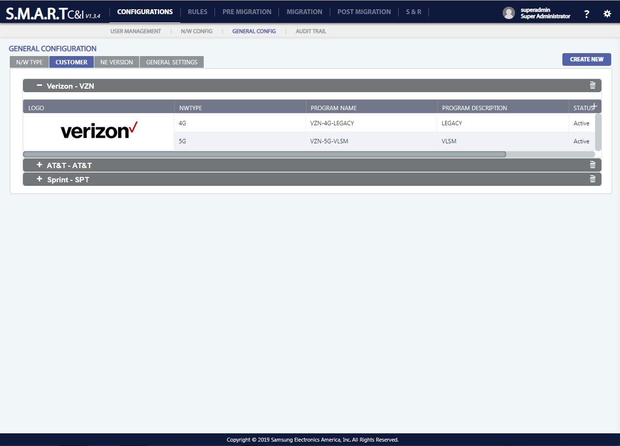

Figure 9: Configurations: General Config - Customer

1. **To create** a customer, Click on Create New Button () placed on top left position of the data table and enter the mandatory fields which are customer name, customer short name, upload logo, NW Type and program name.
2. **To add** a customer record, click on add Button () placed on top right position of the data table.
3. **To edit** customer details, click on the edit icon () appearing when roll over on a user details record. NW Type, program name, program description and status are editable parameters.
4. **To delete** customer detail, click on the delete icon () appearing, when roll over on a user detail record. A confirmation popup with “YES/NO” options appears on click of delete icon. “YES” will delete the record and “NO” will be redirected to the previous screen

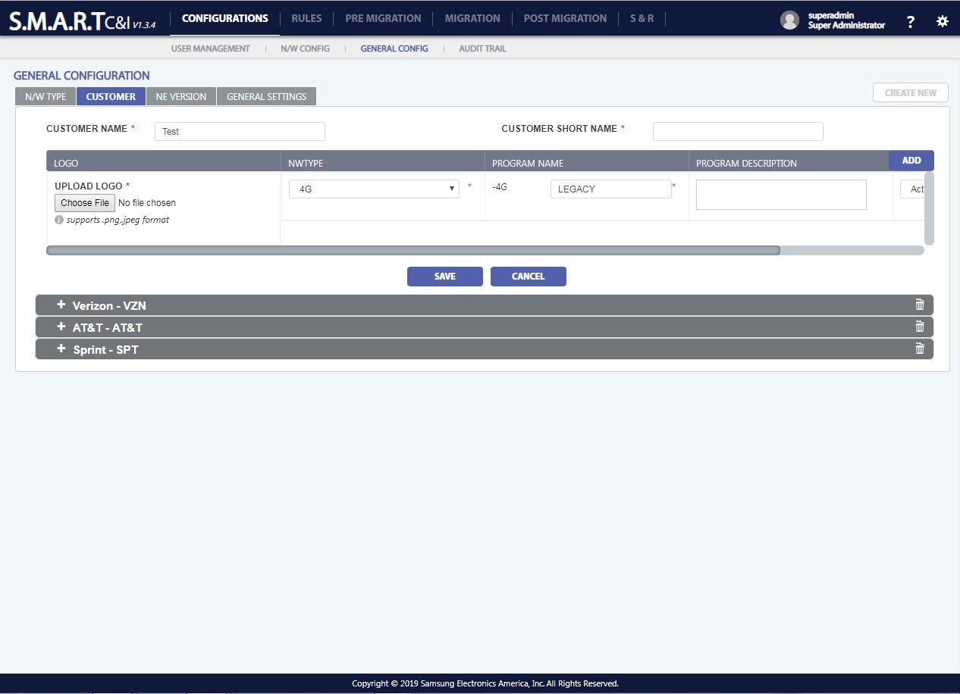

Figure 10: Configurations: General Config - Customer: Create New

#### **NE Version**

The user can create a new NE version based on the program names.

1. **To add** a customer record, click on add Button () placed on top right position of the data table.
2. **To edit** customer details, click on the edit icon () appearing when roll over on a user details record. NW Type, program name, program description and status are editable parameters.
3. **To delete** user detail, click on the delete icon () appearing, when roll over on a user detail record. A confirmation popup with “YES/NO” options appears on click of delete icon. “YES” will delete the record and “NO” will be redirected to the previous screen

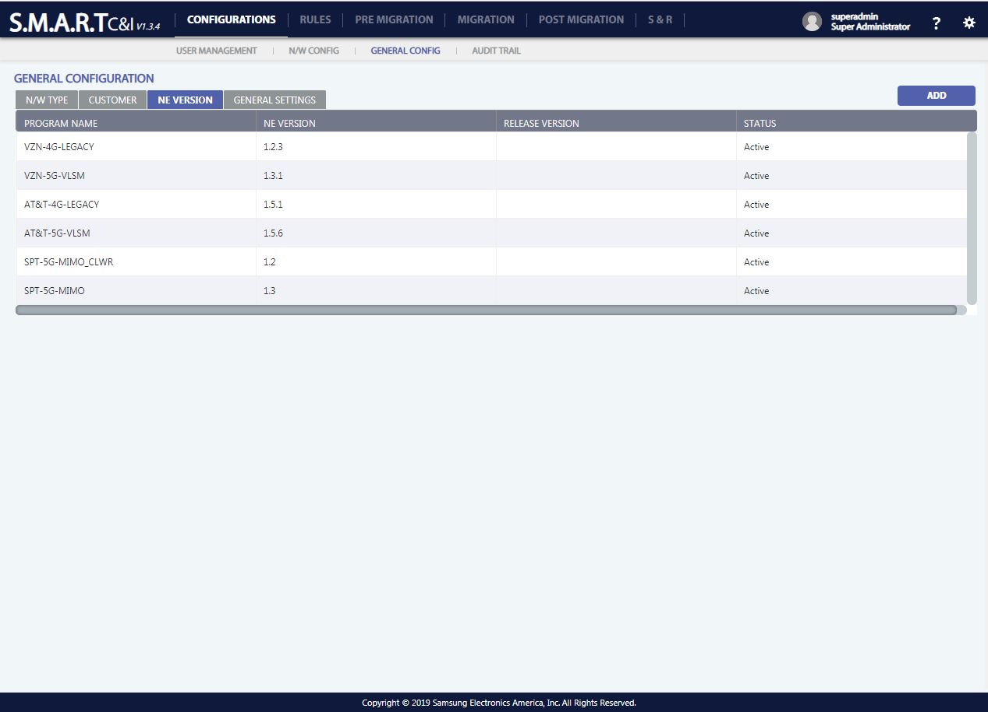

Figure 11: Configurations: General Config – NE Version

#### **Settings**

SMART tool contains the configurations pertaining to session time out of the application and Tool deployment status.

**Session Time Out**: After ‘X’ seconds, the user of the tool will be logged out and by default its 30 Seconds.

**Tool Deployment**: There are two options: LAB and LIVE and by default its LAB.

**History Data**: The tool will display data of past ‘X’ days and by default its 7 days.

**Template**: Each Customer and each program grow template needs to be uploaded in General settings so as to validate the input CIQ against this template.

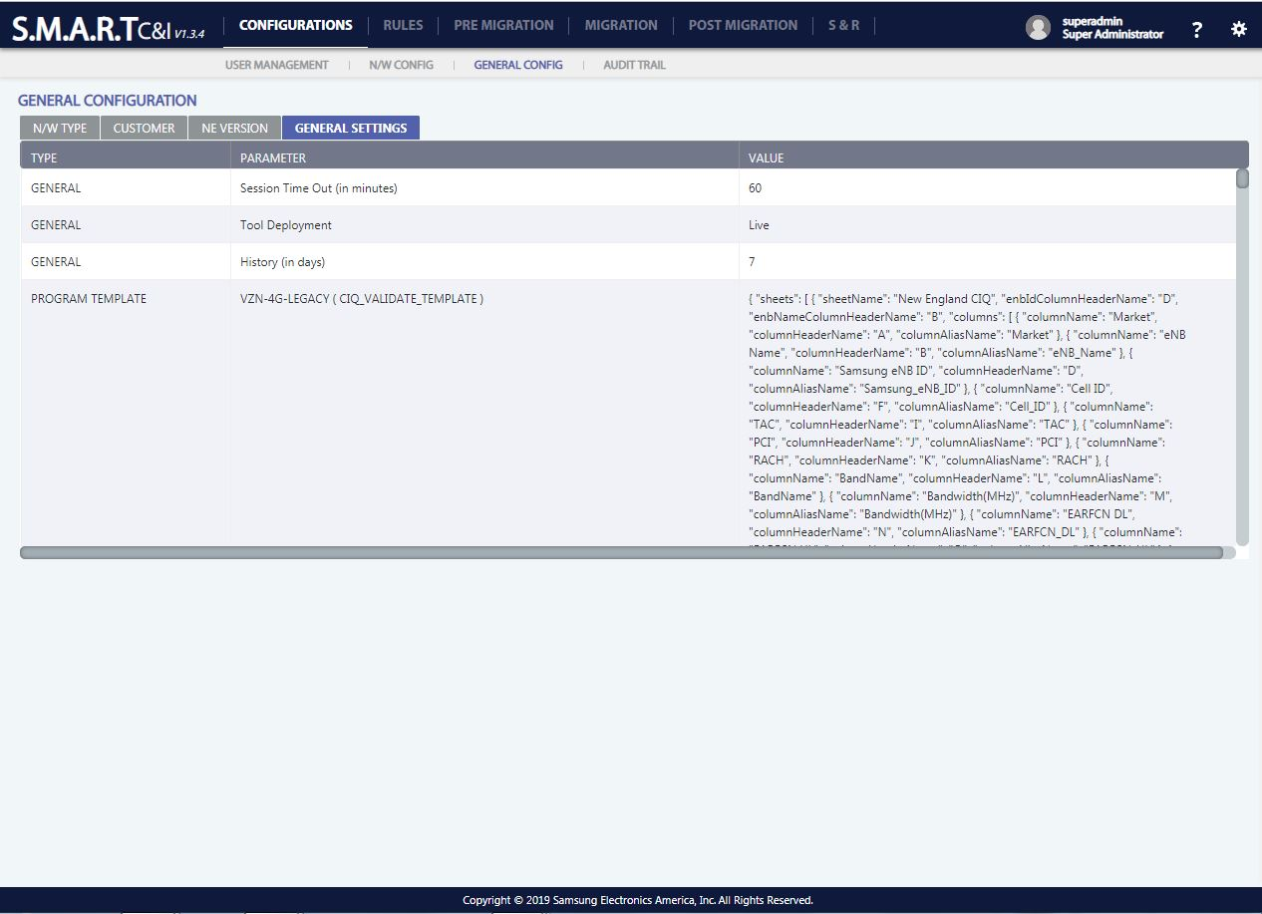

Figure 12: Configurations: General Config - Configuration – General Settings

### **Audit Trail**

The user can access all the events and actions that were performed along with description and timestamp.

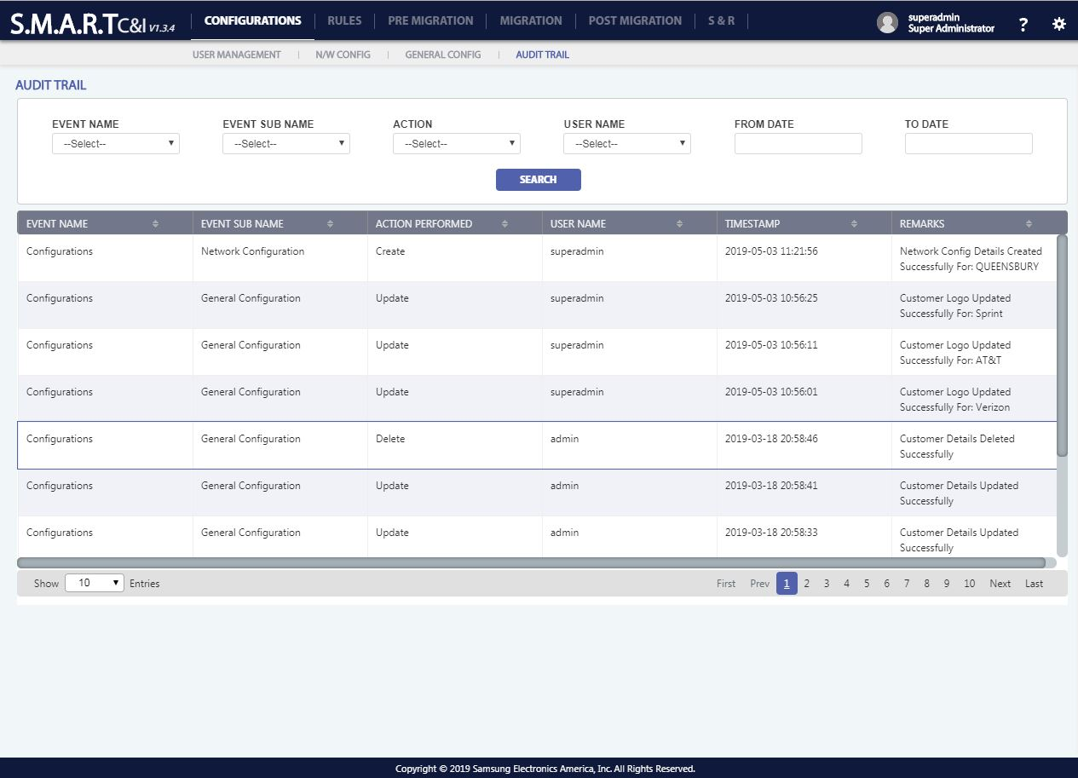

Figure 13: Configurations - Audit Trial

## **Rules**

Rules is used to upload scripts and create File Rules, Command Rules and Use cases which contains the created File rules, command rules executed in a sequence.

#### **Script Store**

All commands that will be executed during the commissioning process needs to be uploaded so that it can be used further by the command rule builder and use case builder.

All the scripts are segregated according to

1. Pre-Migration,
2. Migration,
3. Post Migration.

All the scripts that are needed for commissioning process are uploaded and saved according to which phase the script shall be used.

Script Store consists of two options:

1. Upload Script: All existing command scripts are uploaded

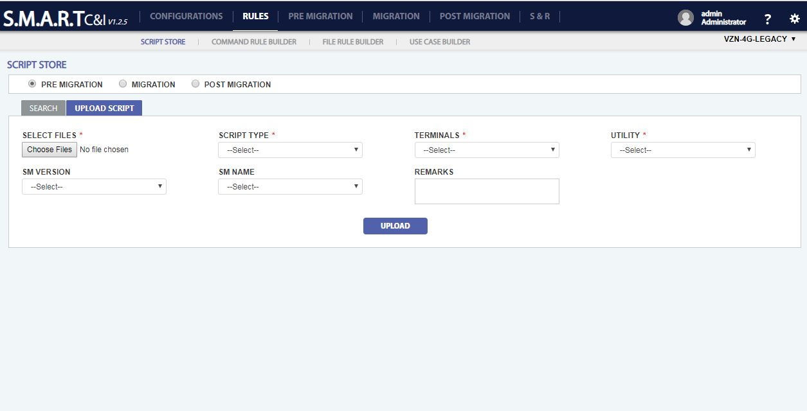

Figure 14: Rules – Script Store: Upload Command

1. Search: Existing commands can be searched based on Filename, state and uploaded by criteria.

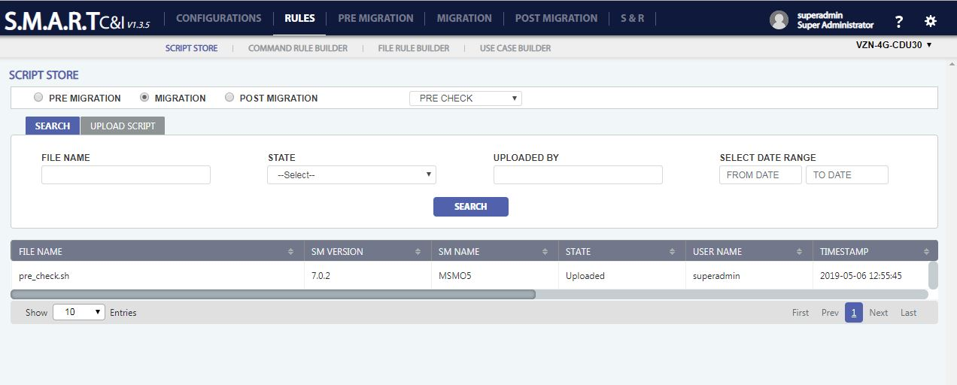

Figure 15: Rules – Script Store: Search

1. Script Store will give us the flexibility to add, update and delete our rules. Each file rule will be saved into the tool database.
2. **To search** a script store record, click on search Button () placed on top of the data table and enter the required fields to search.
3. **To create** a new script store record, Click on Upload Script Button placed on top left position of the data table and enter the mandatory fields which are Select Files, Script Type, Terminals, Utility.
4. **To edit a** Script Store record, click on the edit icon () appearing when roll over on details record. All fields are editable.
5. **To delete** a Script Store record, click on the delete icon () appearing, when roll over on a script store detail record. A confirmation popup with “YES/NO” options appears on click of delete icon. “YES” will delete the record and “NO” will be redirected to the previous screen.

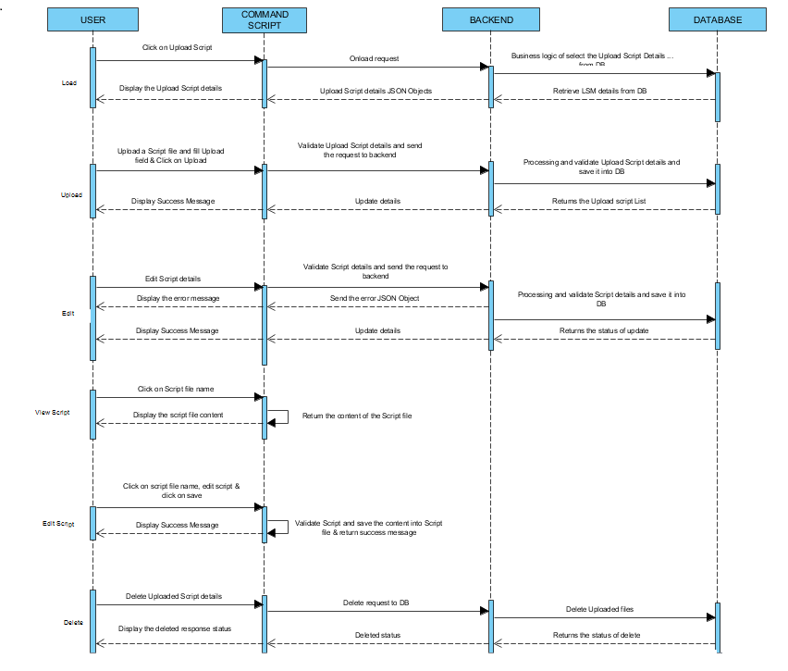

#### **Command Rule Builder**

Command Rule Builder will build rules to validate the commands output. Any number of rules can be added.

All the command rules are segregated according to

1. Pre-Migration,
2. Migration:
   1. Pre-Check
   2. Commission
   3. Post Check
3. Post Migration.
   1. RAN ATP
   2. Audit

Two types of rules can be created CLI/SHELL and XML. User can create/update/delete the command rules. Each command rule will be saved into the tool database

Command Rule Builder consists of two options:

1. Create New: To create new command rules

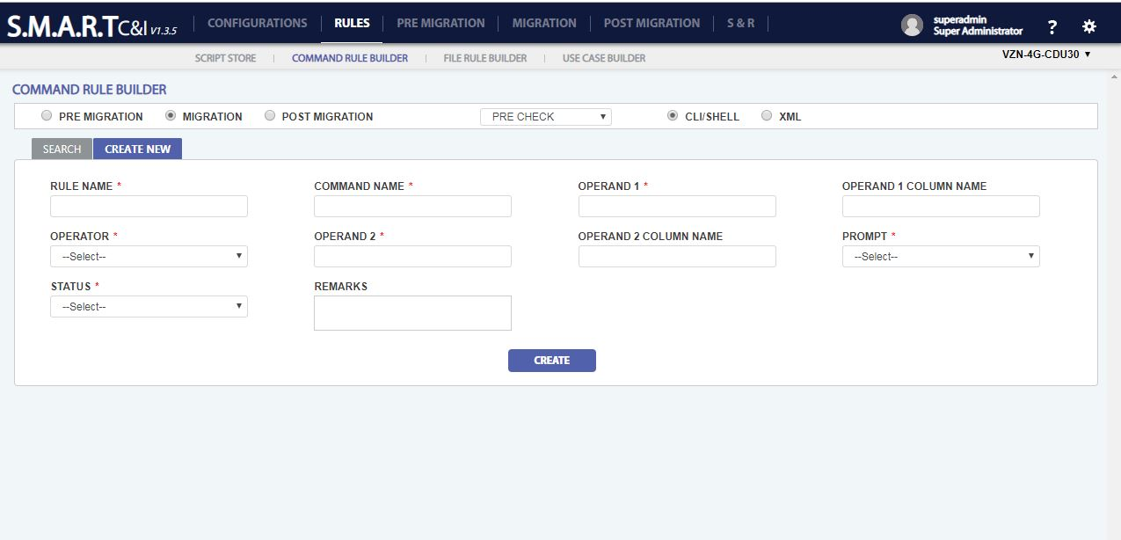

Figure 16: Rules -Command Rule Builder: Create

1. Search: Existing commands can be searched based on Rule Name, Command Name, Operand 1, Operand 2, Prompt and Rule Status by criteria.

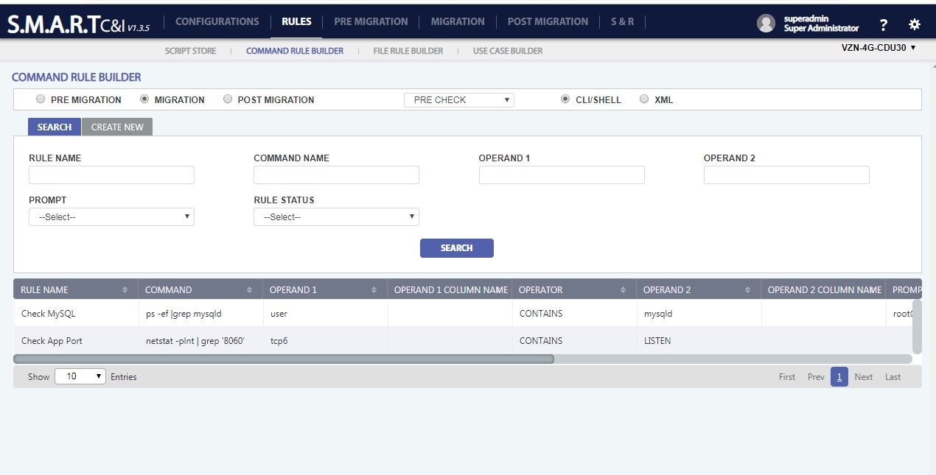

Figure 17: Rules - Command Rule Builder: Search

1. Command Rule Builder will give us the flexibility to add, update and delete our rules. Each command rule will be saved into the tool database.
2. **To search** a Command Rule Builder record, click on search Button () placed on top of the data table and enter the required fields to search.
3. **To create** a new Command Rule Builder record, Click on Create New Button () placed on top left position of the data table and enter the mandatory fields which are Rule Name, Command Name, Operand1, Operator, Operand2, Prompt, Status.
4. **To edit a** Command Rule Builder record, click on the edit icon () appearing when roll over on details record. All fields are editable.
5. **To delete** a Command Rule Builder record, click on the delete icon () appearing, when roll over on a scheduling detail record. A confirmation popup with “YES/NO” options appears on click of delete icon. “YES” will delete the record and “NO” will be redirected to the previous screen.

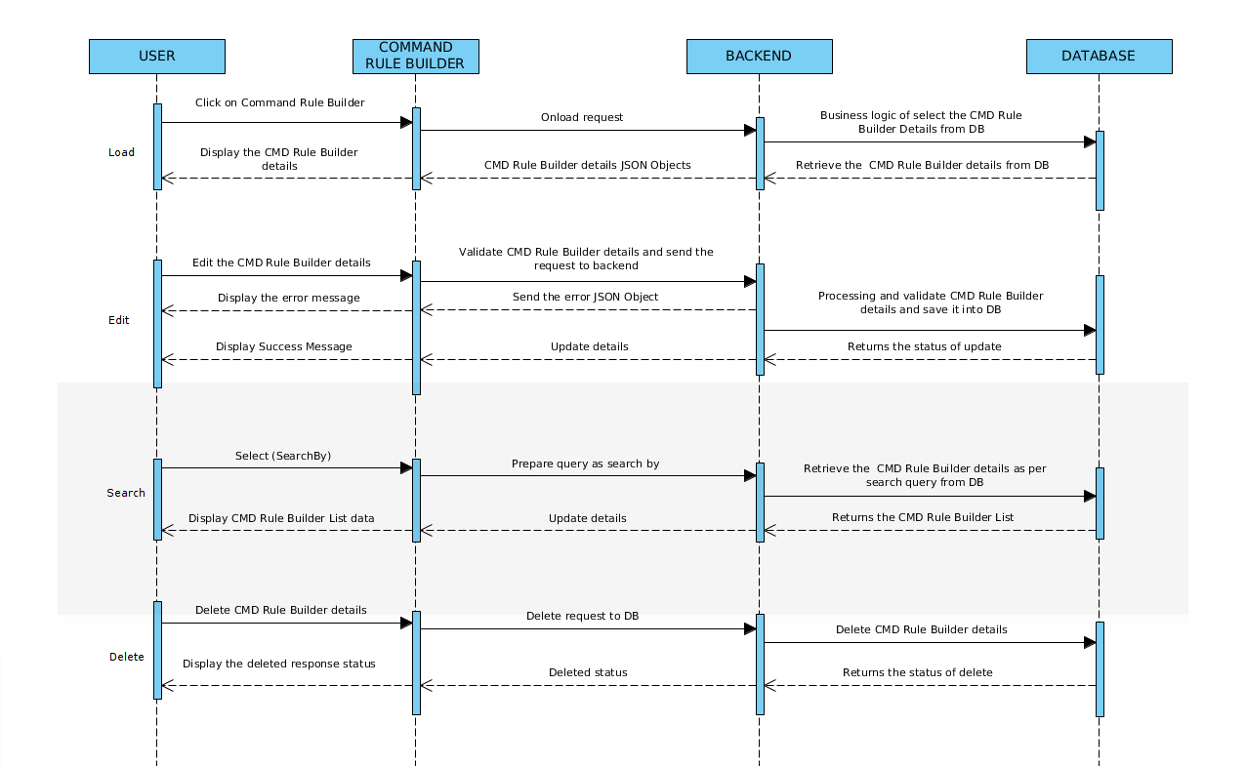

#### **File Rule Builder**

File Rule Builder is like Command Rule Builder. Here the rules will be built for the log file and validate the log file contents.

All the command rules are segregated according to

1. Pre-Migration,
2. Migration:
   1. Pre-Check
   2. Commission
   3. Post Check
3. Post Migration.
   1. RAN ATP
   2. Audit

File Rule Builder consists of two options:

1. Create New: To create new file rules

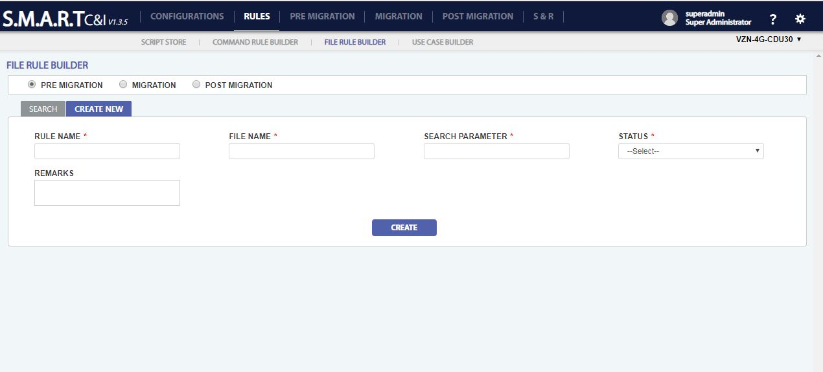

Figure 18: Rules: File Builder – Create

1. Search: Existing commands can be searched based on Rule Name, File Name, Search Parameter and Status by criteria.

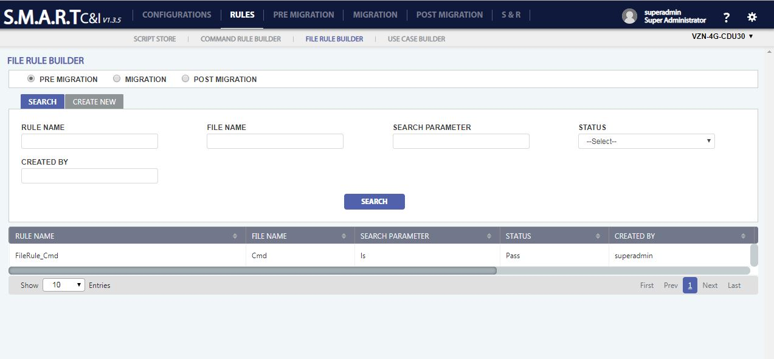

Figure 19: Rules: File Builder – Search

1. File Rule Builder will give us the flexibility to add, update and delete our rules. Each file rule will be saved into the tool database.
2. **To search** a File Rule Builder record, click on search Button () placed on top of the data table and enter the required fields to search.
3. **To create** a new File Rule Builder record, Click on Create New Button () placed on top left position of the data table and enter the mandatory fields which are Rule Name, File Name, Search Parameter, Status.
4. **To edit a** File Rule Builder record, click on the edit icon () appearing when roll over on details record. All fields are editable.
5. **To delete** a File Rule Builder record, click on the delete icon () appearing, when roll over on a scheduling detail record. A confirmation popup with “YES/NO” options appears on click of delete icon. “YES” will delete the record and “NO” will be redirected to the previous screen.

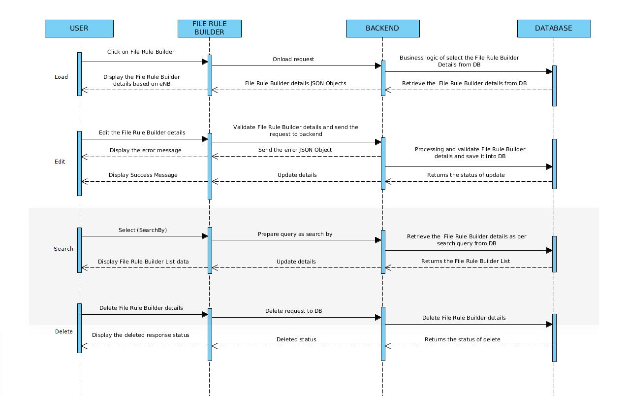

#### **Use case Builder**

Use case will be created using the combination of multiple commands or scripts. For analysis if a set of commands should be executed that will be built as a single use case. With respect to different user requirements we will be making different use case which will be having a set of commands or scripts.

All the command rules are segregated according to

* Pre-Migration,
* Migration:
  + Pre-Check
  + Commission
  + Post Check
* Post Migration.
  + RAN ATP
  + Audit

Use Case Builder consists of two options:

1. Create New Use Case with Script: Enter the mandatory fields Use Case Name, Execution sequence, select script (Uploaded in script store), script execution sequence.
2. Create New Use Case with cmd/xml/file rule: Enter the mandatory fields Use Case Name, Execution sequence, select script (Uploaded in script store), script execution sequence, Rule , Rule occurrence.

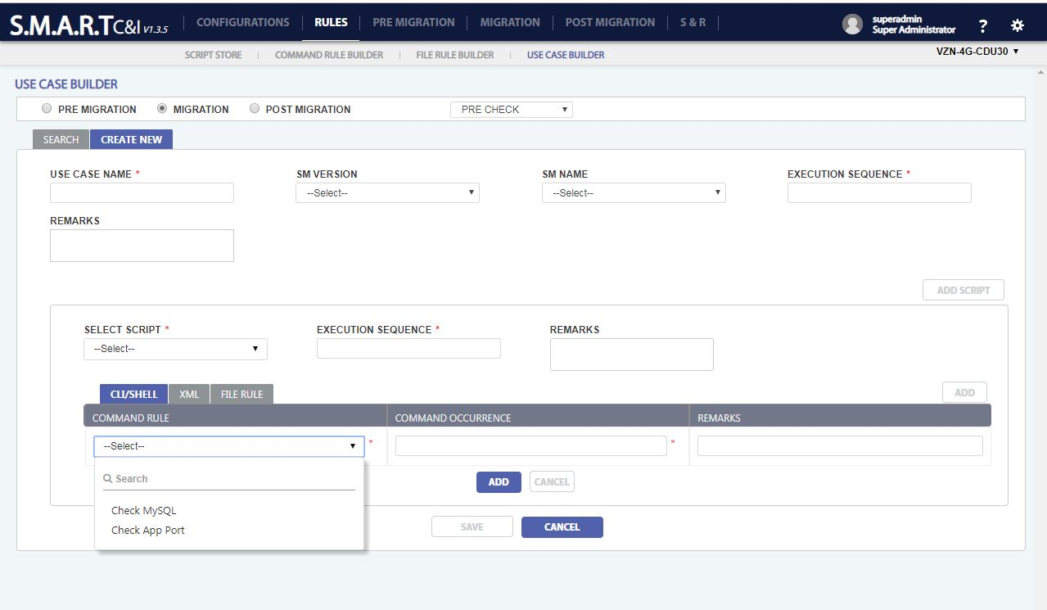

Figure 20: Rules: Use Case Builder – Create

1. Search: Existing commands can be searched based on Use Case Name, SM Version, SM Name and Creation by criteria.

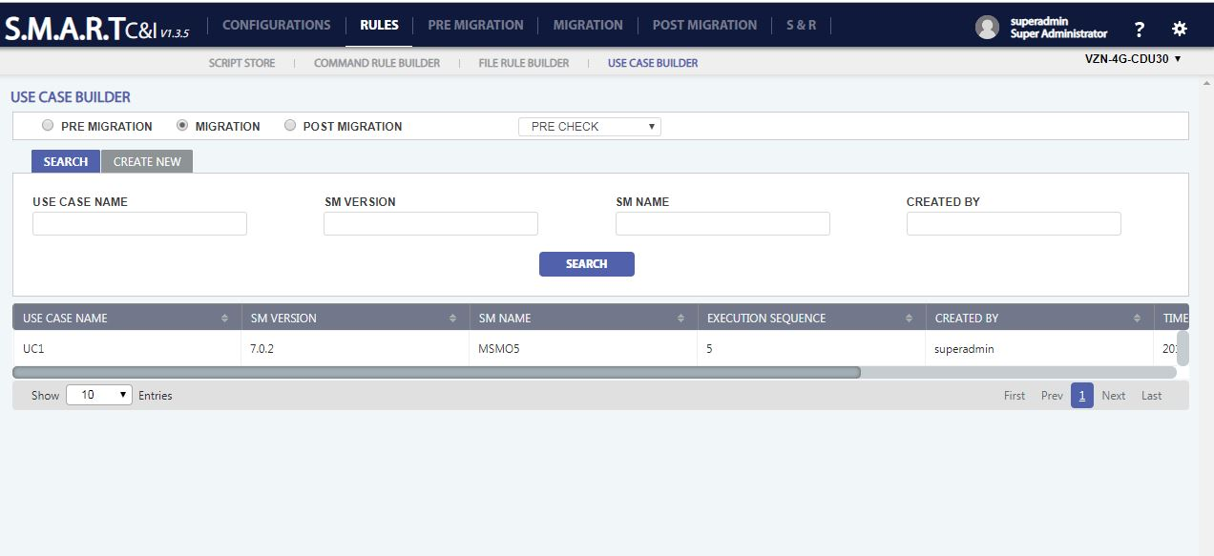

Figure 21: Rules: Use Case Builder – Search

1. Use Case Builder will give us the flexibility to add, update and delete our rules. Each use case rule will be saved into the tool database.
2. **To search** a Use Case Builder record, click on search Button () placed on top of the data table and enter the required fields to search.
3. **To create** a new Use Case Builder record, Click on Create New Button () placed on top left position of the data table and enter the mandatory fields which are Use Case Name, Execution sequence, Select Script, Execution sequence.
4. **To edit a** Use Case Builder record, click on the edit icon () appearing when roll over on details record. All fields are editable.
5. **To delete** a Use Case Builder record, click on the delete icon () appearing, when roll over on a scheduling detail record. A confirmation popup with “YES/NO” options appears on click of delete icon. “YES” will delete the record and “NO” will be redirected to the previous screen.

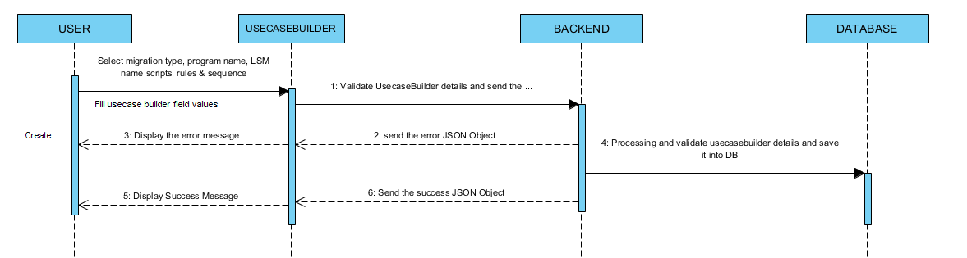

* Combination of multiple commands or scripts will make a use case. This module will also allow us to add some more use cases in future by adding new set of commands and scripts. Each use case will be part of commissioning step.
* The authorized user can create/update/delete the use case. The use case builder will create the link between command/script and command rule. One use case might contain multiple rules. Each use case would be saved into tool database.
* Scripts and Use cases will get executed in the order of sequence number.

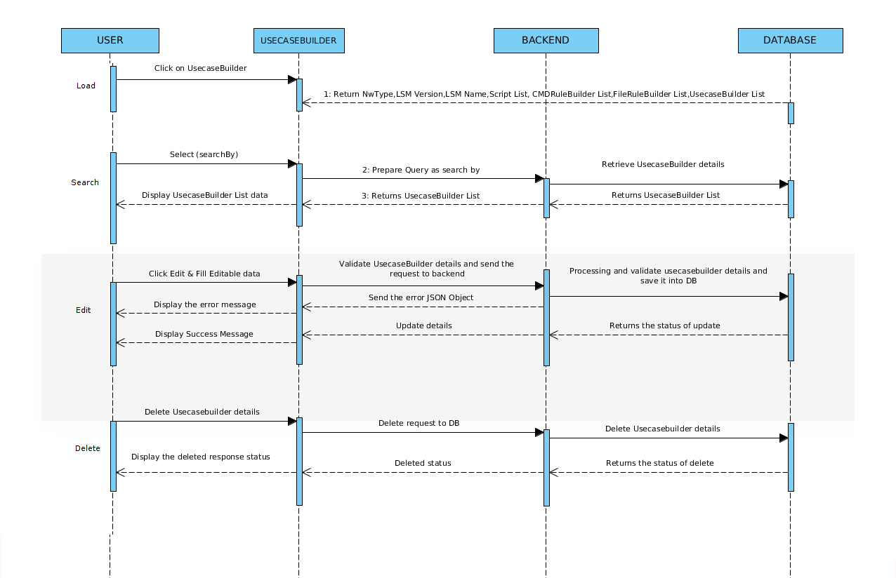

## **Pre-Migration**

SMART tool is used to grow NE’s as per the CIQ provided. In Pre-Migration stage, user can upload the input CIQ files. User can also track the uploaded file in future. User can validate and generate the CSV files according to the CIQ data provided by customer.

### **Block diagram**

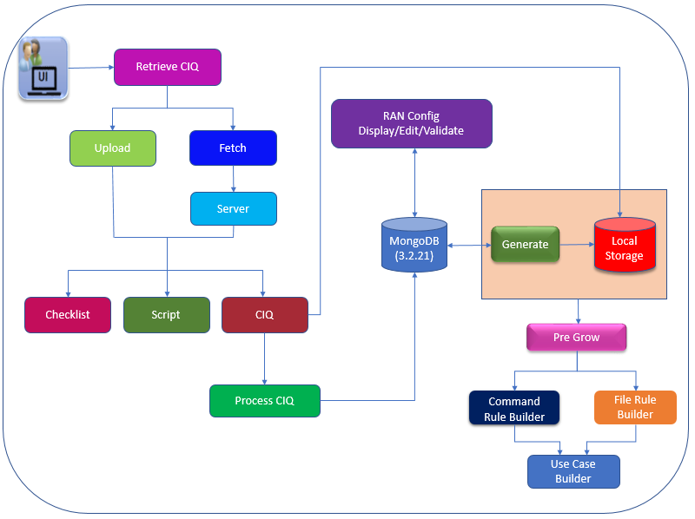

Figure 22: Block Diagram for Pre-Migration

#### **UI**

It is the user interface for the client.

#### **Retrieve CIQ**

Retrieve CIQ page is used to Upload/Fetch the input CIQ, Script and Checklist files from local system or from corresponding servers. These input files will be converted to set of three outputs:

1. CSV file
2. ENV scripts and
3. Commissioning scripts.

All the uploaded/fetched files will be displayed in tabular format.

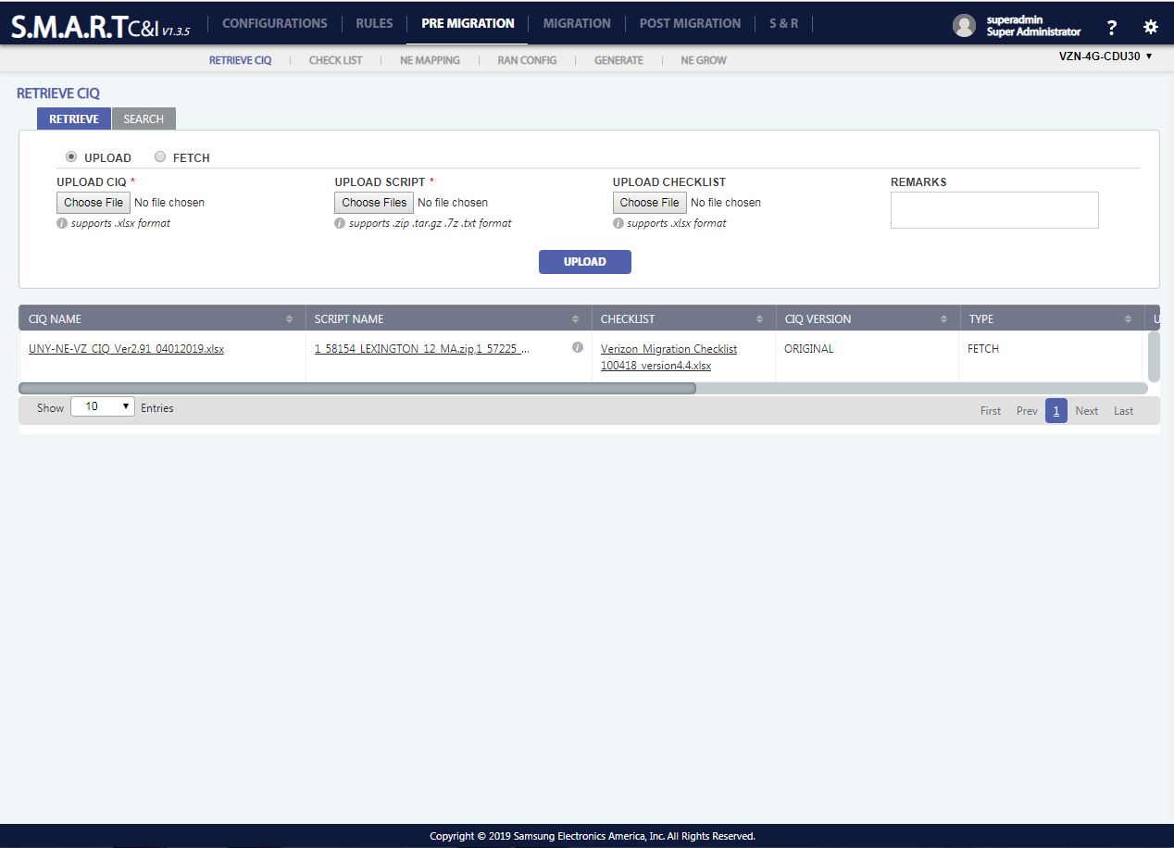

Figure 23: Pre-Migration: Retrieve CIQ - Upload

1. **To edit** CIQ details, click on the edit icon () appearing when roll over on a CIQ details record. Only remark is the editable field.
2. **To delete** CIQ record, click on the delete icon () appearing, when roll over on a user detail record. A confirmation popup with “YES/NO” options appears on click of delete icon. “YES” will delete the record and “NO” will be redirected to the previous screen.

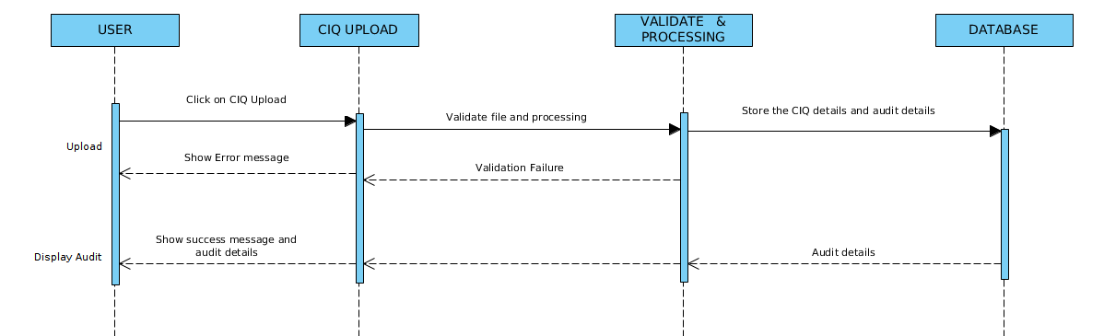

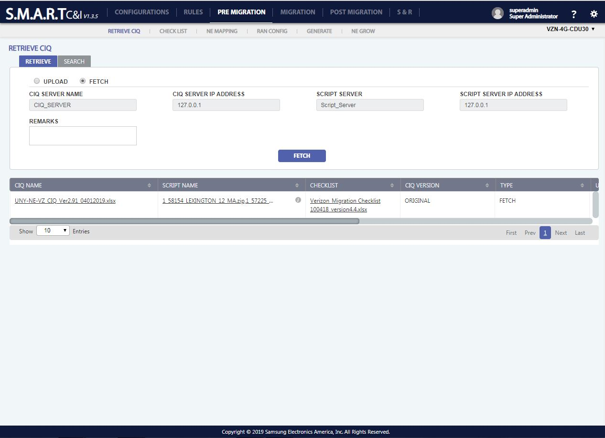

Figure 24: Pre-Migration: Retrieve CIQ - Fetch

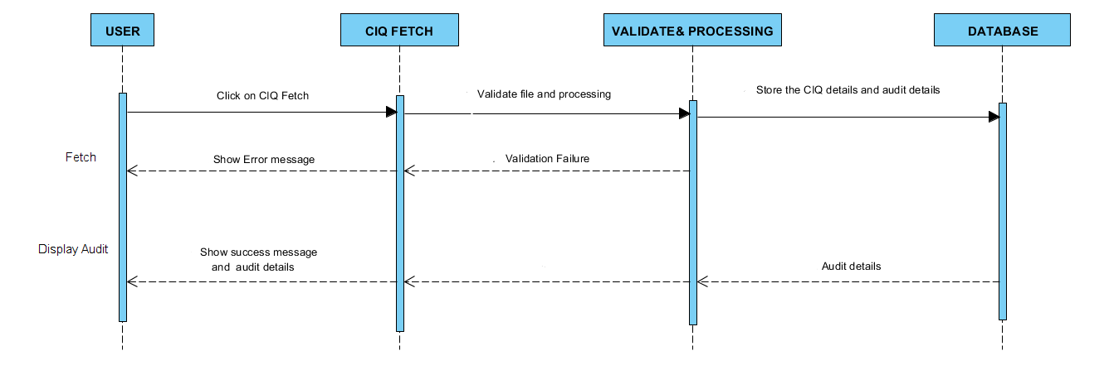

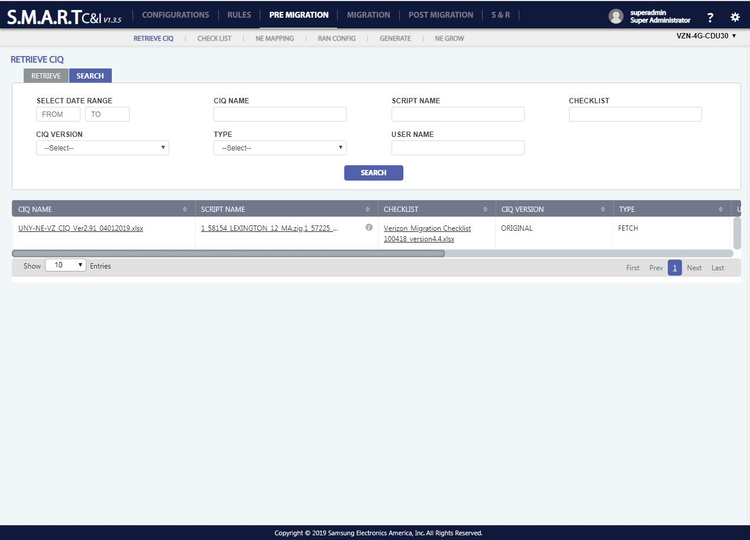

Figure 25: Pre-Migration: Retrieve CIQ - Search

1. **To search** an Uploaded/Fetched CIQ record, click on search Button () placed on top left position of the data table and enter the required fields to search.

#### **Checklist**

User shall be able to search and display for any checklist which has been uploaded/fetched. Depending on the date range selected by the user, all checklists will be populated. Upon selection of the checklist and click on Search, entire contents of Checklist shall be displayed

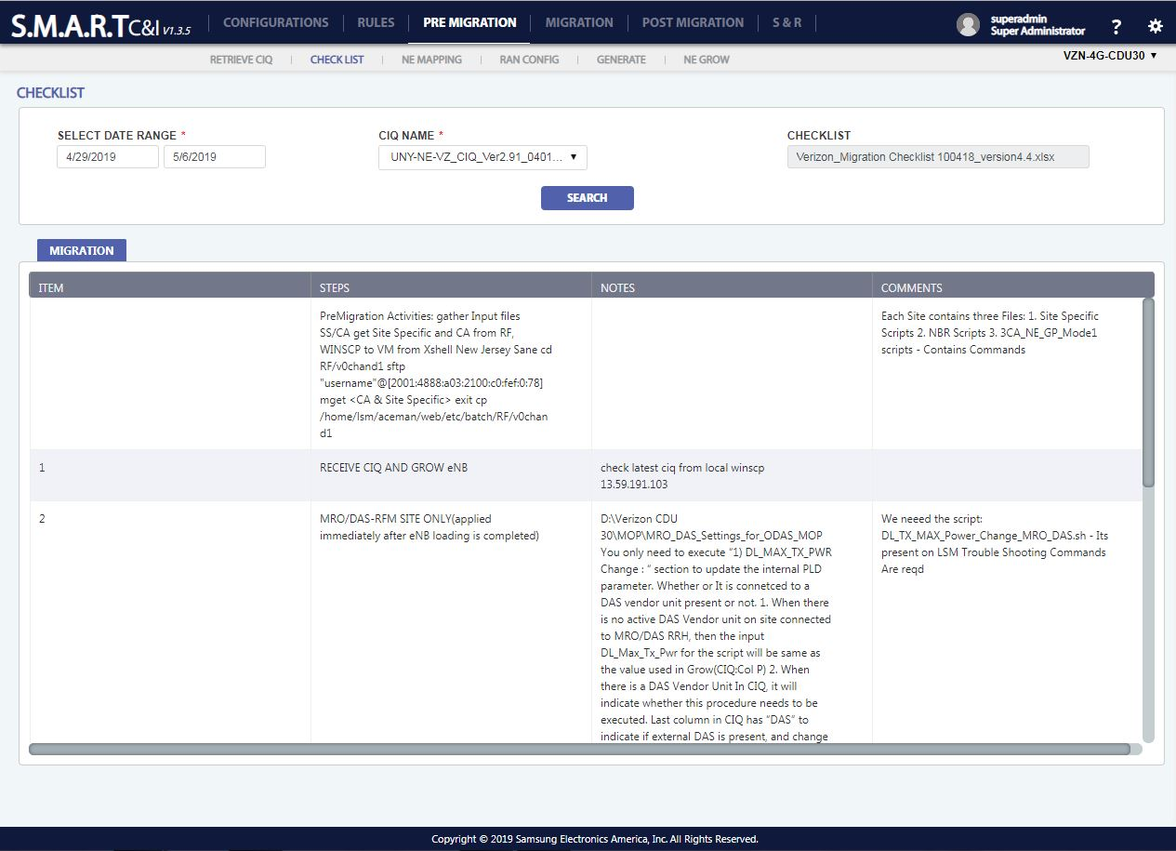

Figure 26: Pre-Migration: Checklist

#### **NE Mapping**

NE Mapping Screen provides functionalities to display the details of NE from the CIQ file which is uploaded in the retrieve CIQ page. The data will get loaded dynamically when a CIQ file is uploaded in the retrieve CIQ page. By default, the page displays the past seven days data.

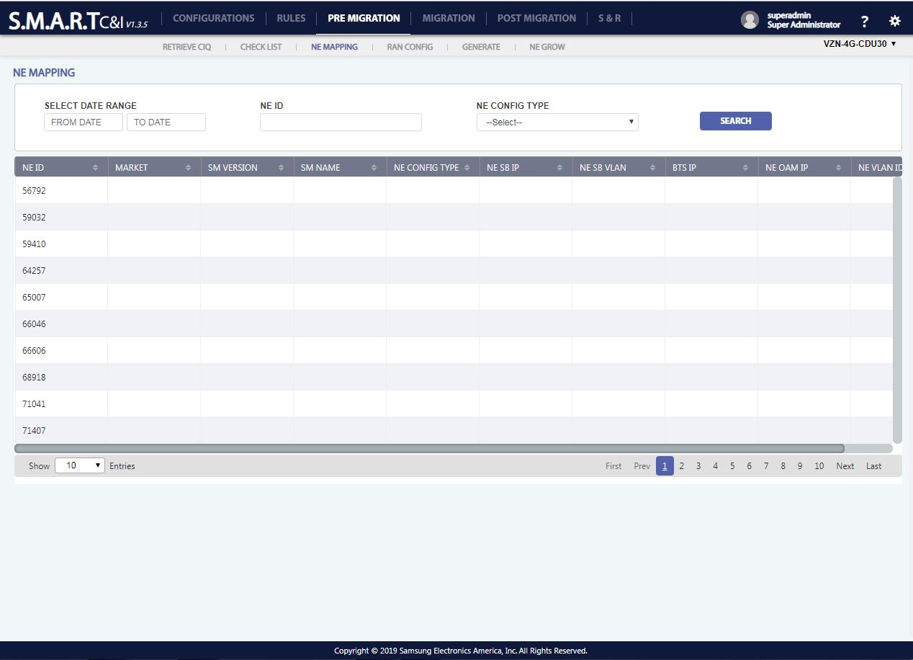

Figure 27: Pre-Migration: NE Mapping

1. **To search** a NE Mapping record, click on search Button () placed on top of the data table and enter the required fields to search.
2. **To edit** NE details, click on the edit icon () appearing when roll over on a user details record. Market, SM Version, SM Name and NE Config Type are editable parameters. NE ID is non – editable parameter.

#### **DB Management:**

Since the data to be stored per NE is huge and dynamic, MongoDB is used to store the CIQ information. It is required to fetch the CIQ data for edit ad validate purpose.

#### **RAN Config**

* In RAN Config, the CIQ information will be fetched from Database. User can edit/add data. But the edited data or newly added data will be saved back in CIQ file, it will be saved in the database. Data will be display in two formats:

1. CIQ Based Search
2. NEs Based Search
   * **CIQ Based Search:** The CIQ data will be displayed based on the file chosen by the user grouped by the NEs Name/ID as shown below. User can edit/add data. But the edited data or newly added data will be saved back in CIQ file, data will be saved in the database.

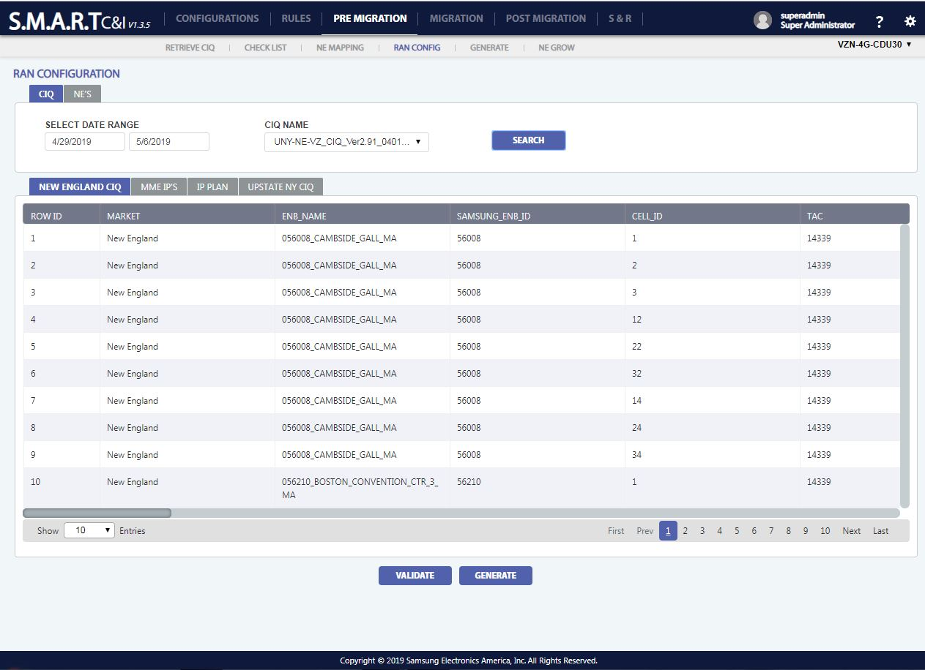

Figure 28: Pre-Migration: Ran-Config - CIQ

1. **To Search** a RAN Config record, click on search Button () placed on top of the data table and enter the required fields to search.
2. **To Clone a** RAN Config record, click on the clone icon () appearing when roll over on a RAN Config details record.
3. **To Edit** RAN Config details, click on the edit icon () appearing when roll over on a RAN Config details record. All fields are editable except row id.
4. **To Delete** RAN Config record, click on the delete icon () appearing, when roll over on a user detail record. A confirmation popup with “YES/NO” options appears on click of delete icon. “YES” will delete the record and “NO” will be redirected to the previous screen.
5. **To Generate** the details, click on the generate icon () appearing below the table data.
6. **To Validate** whether the details are matching with the program template or not, click on the validate icon () appearing below the table data.

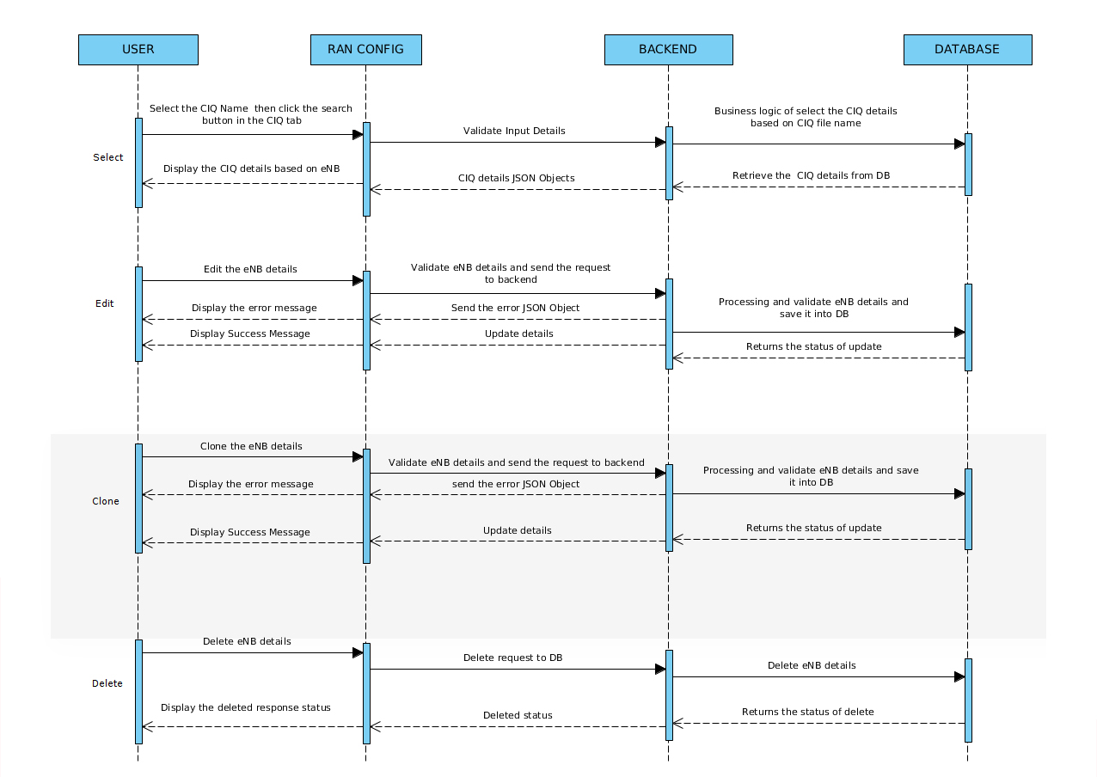

* + **NEs Based Search:** Single NE data will be displayed from a use chosen CIQ File. User can select the CIQ filename and the corresponding NE name. Data pertaining to the selected NE will be displayed in a tabular form and it can be edited.

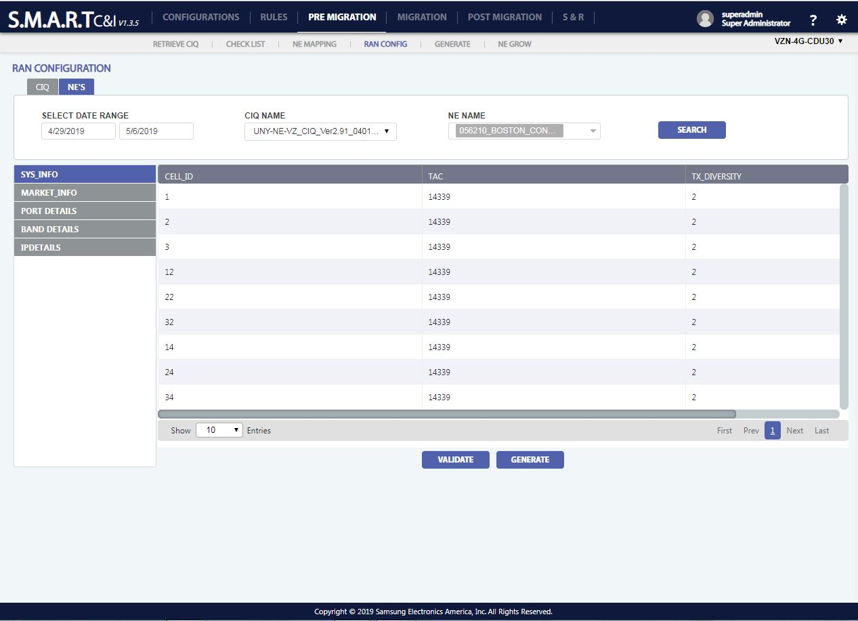

Figure 29: Pre-Migration: Ran-Config – NE’s

1. **To Search** a RAN Config record, click on search Button () placed on top of the data table and enter the required fields to search.
2. **To Edit** RAN Config details, click on the edit icon () appearing when roll over on a RAN Config details record. All fields are editable except row id.
3. **To Generate** the details, click on the generate icon () appearing below the table data.
4. **To Validate** whether the details are matching with the program template or not, click on the validate icon () appearing below the table data.

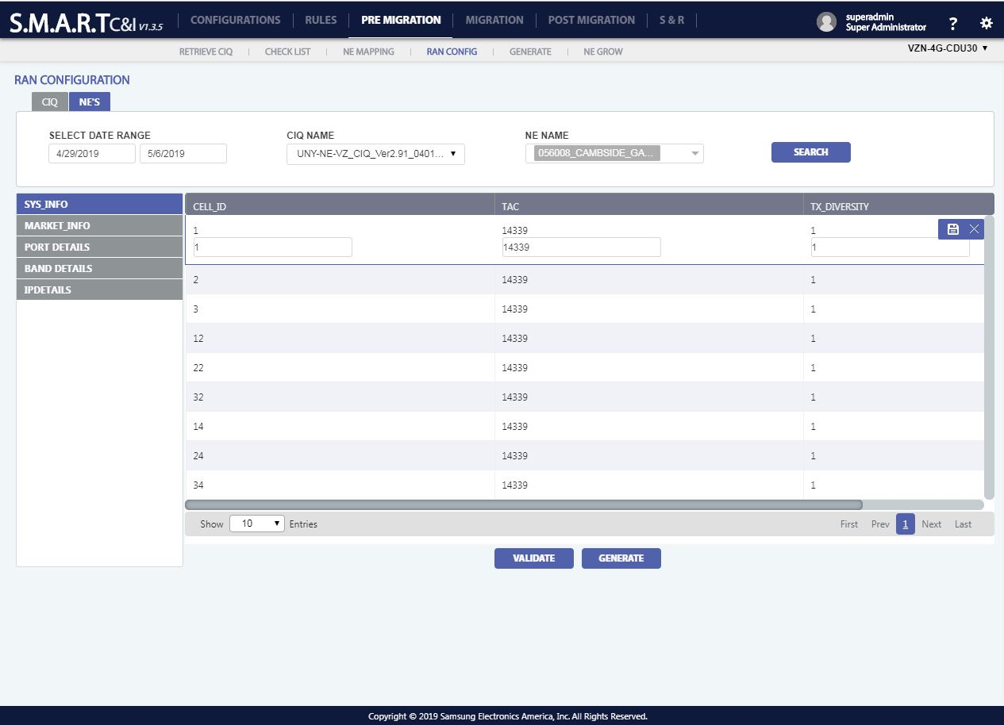

Figure 30: Pre-Migration: Ran-Config – NE’s - Edit



* Once the data is validated, the user can click on the generate button for generating the output (CSV) file.

#### **Generate**

Generate functionality will generate three sets of outputs:

1. Env File: Env Scripts shall be generated upon validation.

2. Grow Template: CSV file shall be generated upon validation.

3. Commissioning Script: Commissioning scripts shall be generated upon validation.

Each output file can be generated separately using the different menu’s being provided in the Generate screen.

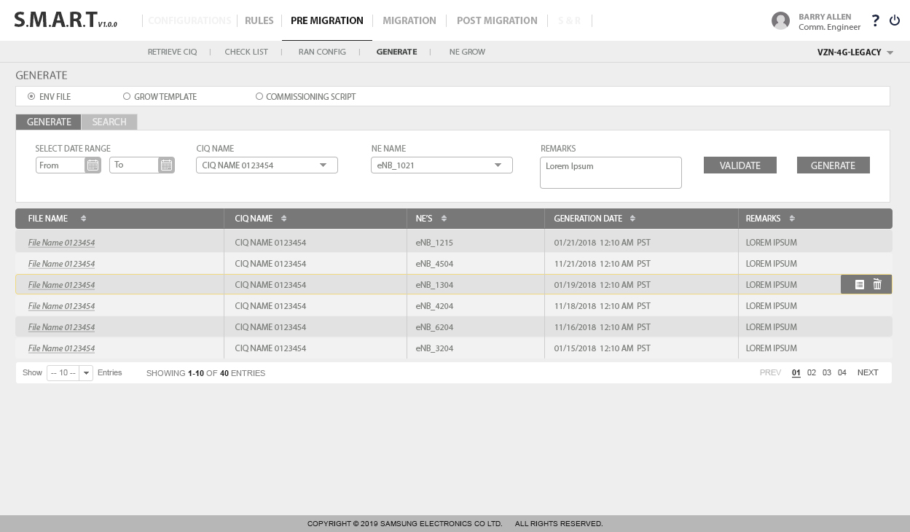

Figure 31: Pre-Migration: Generate

1. **To Search** a generated record, click on search Button () placed on top of the data table and enter the required fields to search.
2. **To Mail a** file, click on the mail icon () appearing when roll over on a generate details record.
3. **To Edit** file details, click on the edit icon () appearing when roll over on a generate details record. All fields are editable except row id.
4. **To Delete** record, click on the delete icon () appearing, when roll over on a user detail record. A confirmation popup with “YES/NO” options appears on click of delete icon. “YES” will delete the record and “NO” will be redirected to the previous screen.
5. **To Generate** the details, click on the generate icon () appearing below the table data.
6. **To Validate** whether the details are matching with the program template or not, click on the validate icon () appearing below the table data.

User can search for the uploaded files by giving date range, CIQ File, NE Name, Grow Template, SM Version and SM Name as input.

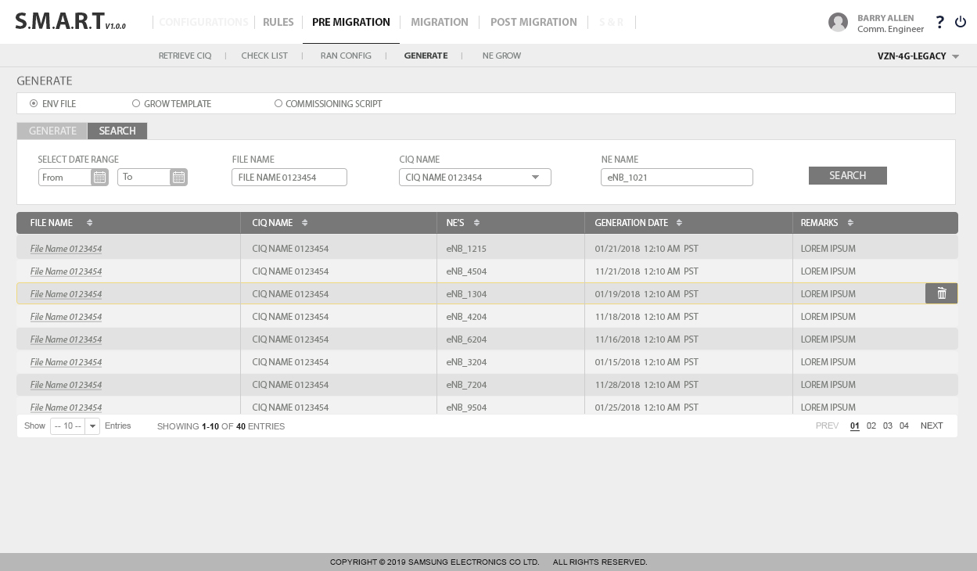

Figure 32: Pre-Migration: Generate: Search

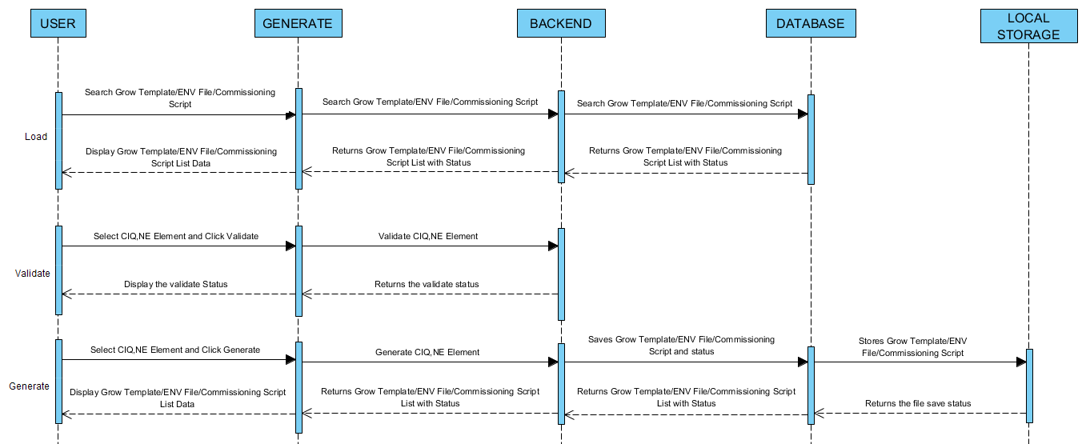

#### **Local storage:**

Once the CSV is generated from CIQ file it will be stored in server machine local storage. The path of the output will be displayed along with the status of the CSV generation in the generate tab.

#### **NE Grow**

In NE Grow section, all the generated output files will be listed. User can select the required files based on the date range, CIQ File, NE Name, grow template, SM Version and SM Name as input and can ask for grow.

Before growing, user can test the connection by clicking on “Check Connection”

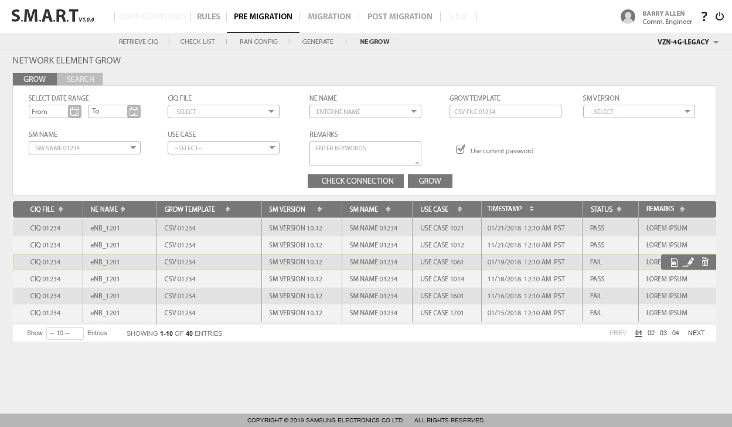

Figure 33: Pre-Migration: NE Grow: Grow

User can search the files based on the date range, CIQ File, NE Name, grow template, SM Version and SM Name as input and can ask for grow.

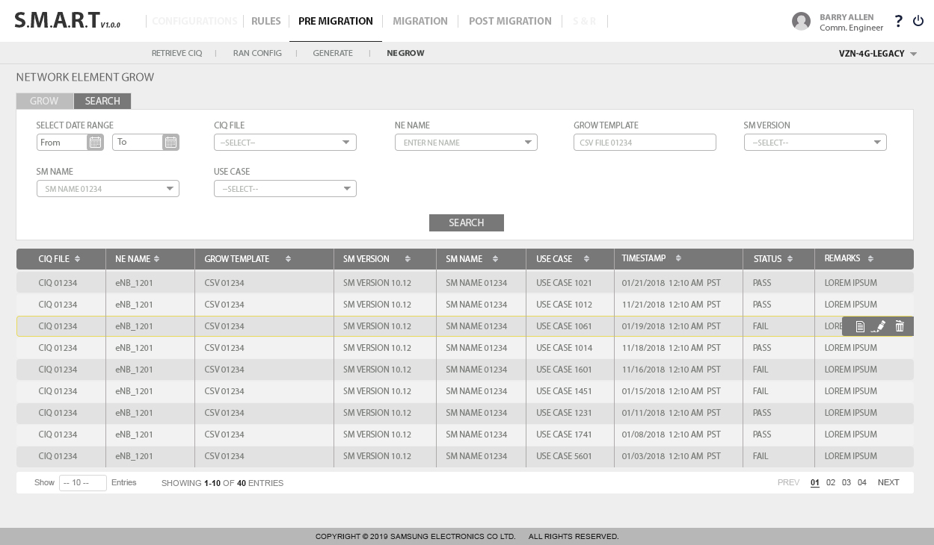

Figure 34: Pre-Migration: NE Grow: Search

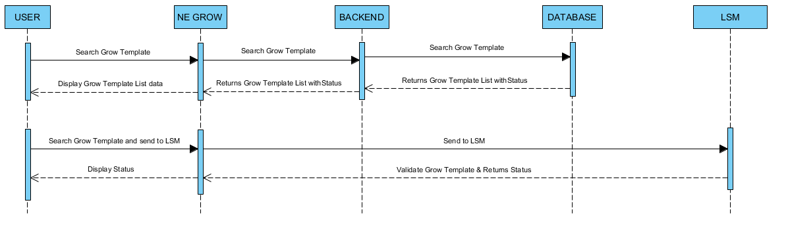

User can click on the report button for a specific row and view the report which includes all the results of command rules, file rules and scripts associated.

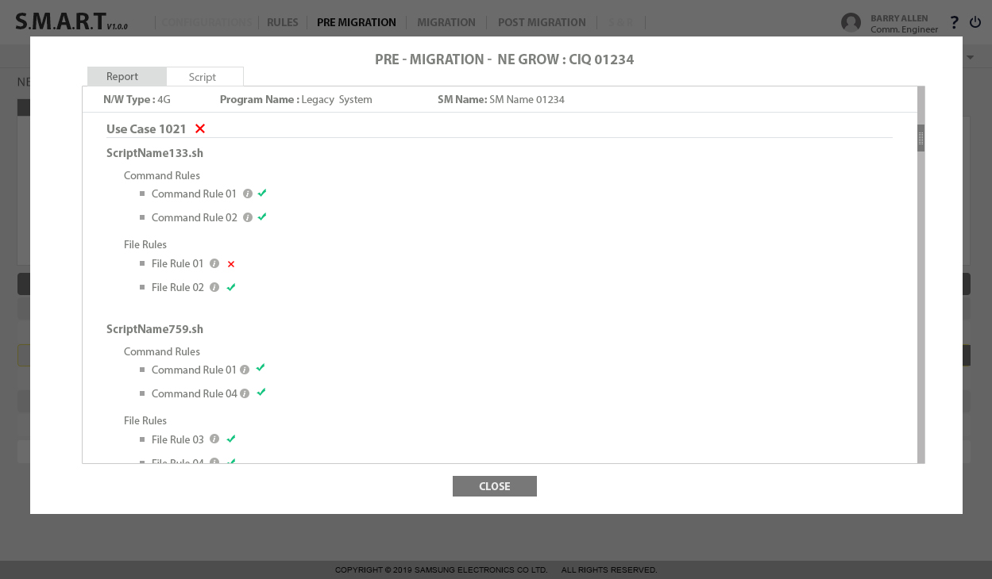

Figure 35: Pre-Migration – Report View

User can click on the report button for a specific row and view the scripts associated with it. User needs select use case and scripts associated with that use case and click on view. The script will be displayed.

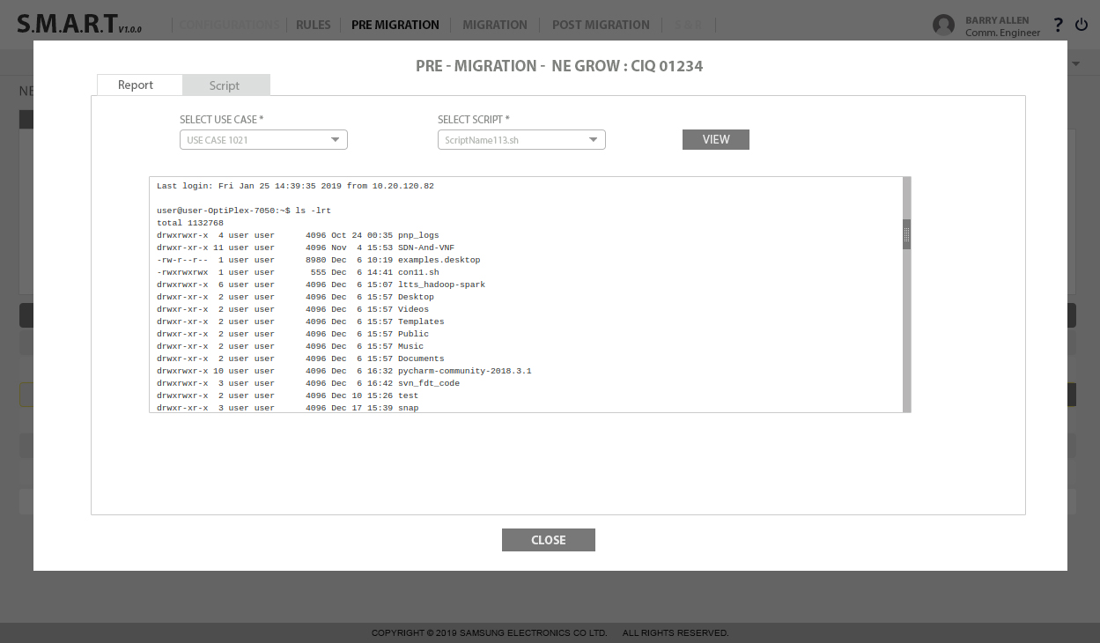

Figure 36: Pre-Migration – Script View

## **Migration**

Migration is used to commission the NEs. Commissioning includes multiple steps.

Each step may execute multiple commands or scripts and the commissioning steps may vary as per the customer.

Migration will run the selected use cases on selected network element.

* Use case will get executed based on the execution sequence number.
* All the scripts in use case also will be executed based on the execution sequence number.
* Rules will be applied on the script output based on command occurrence.
* All the use case will get executed on the selected network element and the output will be captured from all the network element type.

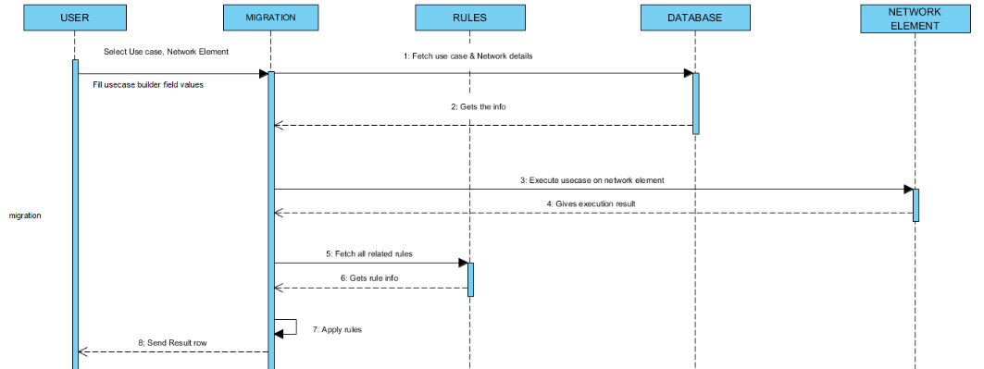

### **Block diagram**

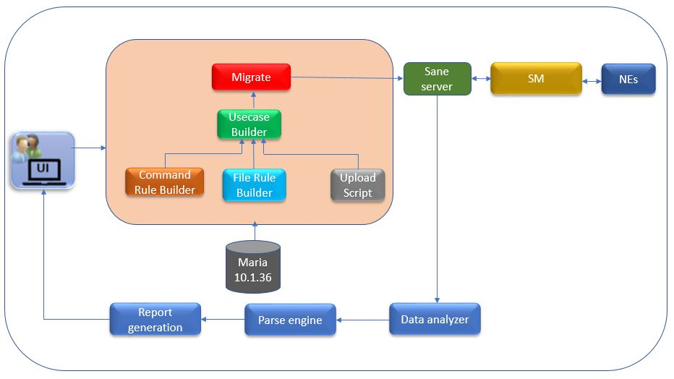

Figure 37: Block Diagram for Migration

#### **UI**

It is the user interface for the client.

#### **Command Store**

Scripts are uploaded by user

#### **Command Rule Builder**

The user can create rules for command execution.

#### **File Rule Builder**

The user can create rules for command execution.

#### **Use Case Builder**

Use Case Builder is created using command rule builder and file rule builder and scripts.

#### **SANE Server**

The SANE server is the jump server, from which client servers can be accessible.

#### **Data analyzer**

Data analyzer will fetch the output of the script execution and send it to parser engine.

#### **Parse Engine**

* Parser engine will take input data from data analyzer and parse the output based on the command rule parameters. Our actual business logic will be residing here.
* This will have all our business logic to parse the command and script to get the desired result.
* It will parse the result and give a refined required result.

#### **Report /Result Generator**

Result generator will use the parsed data and generate a user-friendly result and pass the output to UI.

#### **Migrate**

Migration Page will list all the use cases which are basically the commissioning steps.

Migration is divided into three steps:

1. Precheck
2. Commission
3. Post check

User can select the use cases and execute them in sequence.

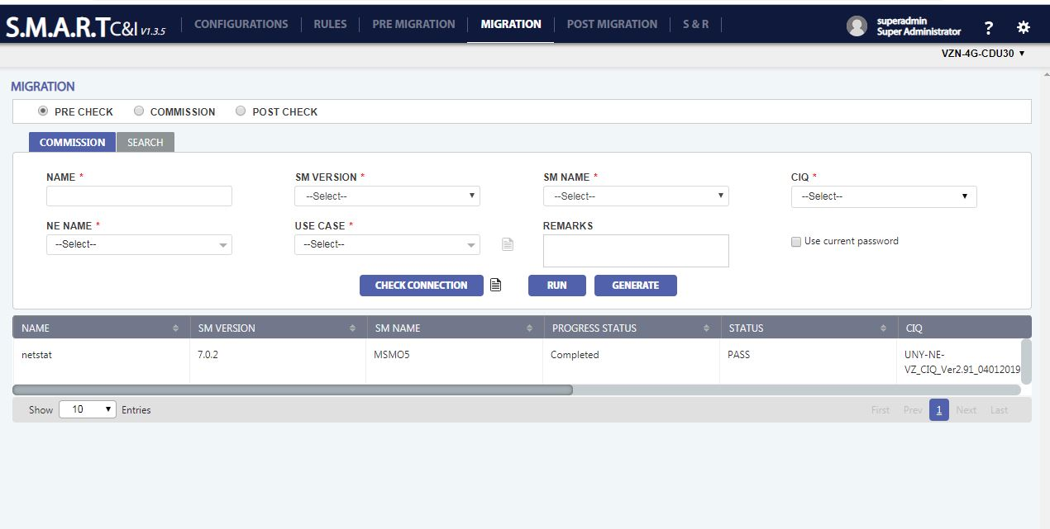

Figure 38:Migration: Commission

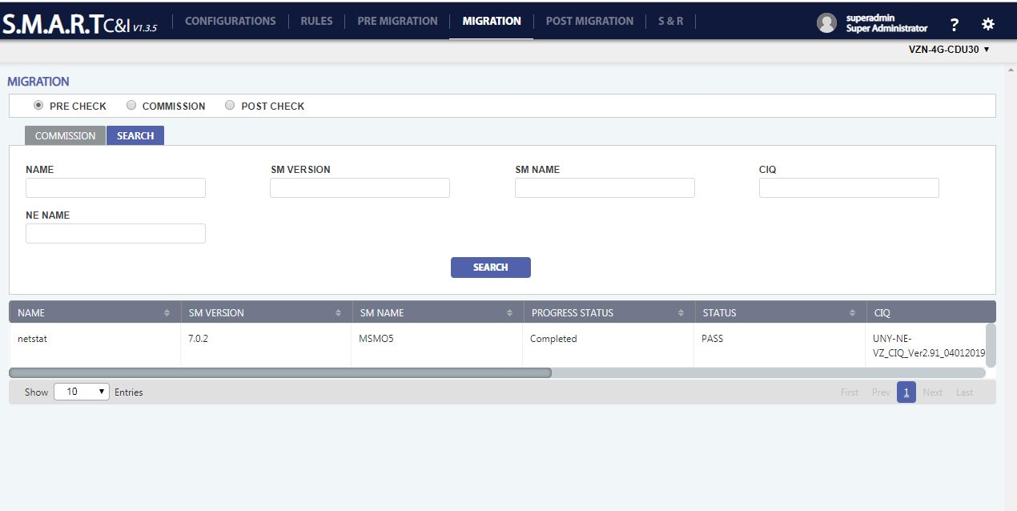

Figure 39:Migration: Search

User shall be able to change the commissioning procedure sequences.

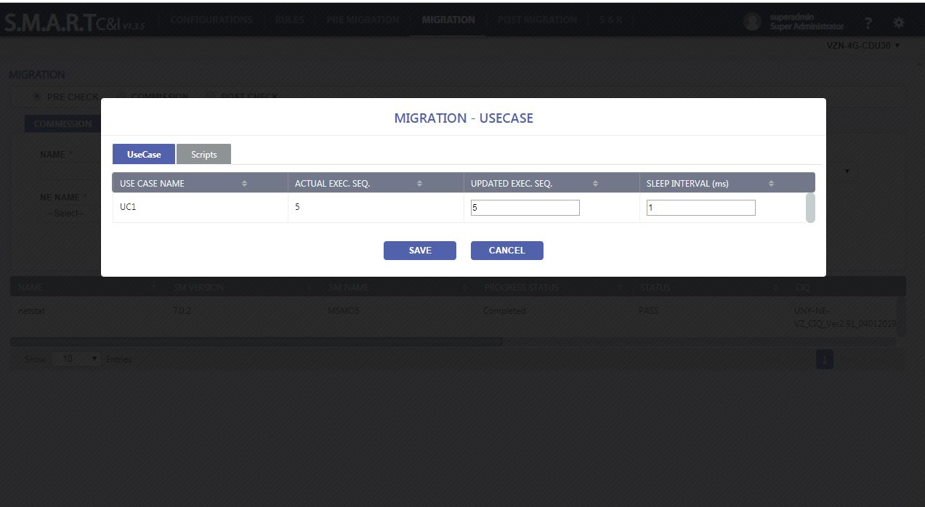

Figure 40:Migration: Use Case Execution Sequence

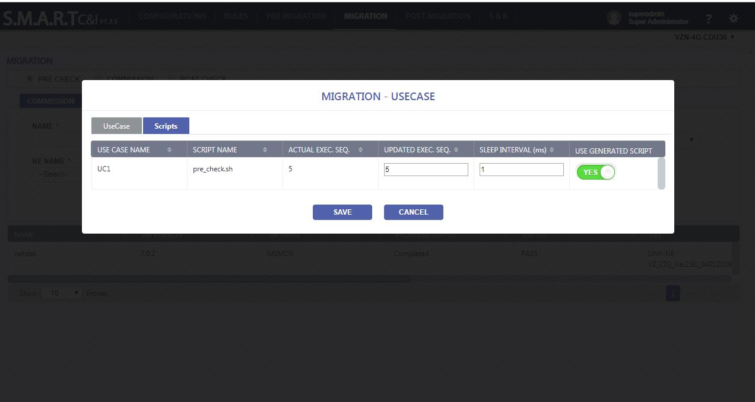

Figure 41: Migration: Script Execution Sequence

User shall be able to generate the script on click of Generate Button.

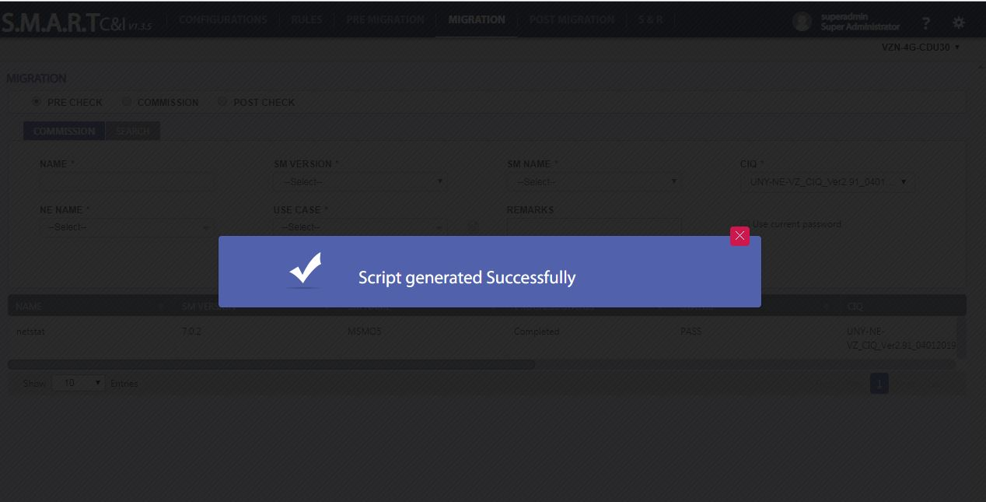

Figure 42: Migration: Script Generate

User shall be able to download the output on click of Download Logs icon.

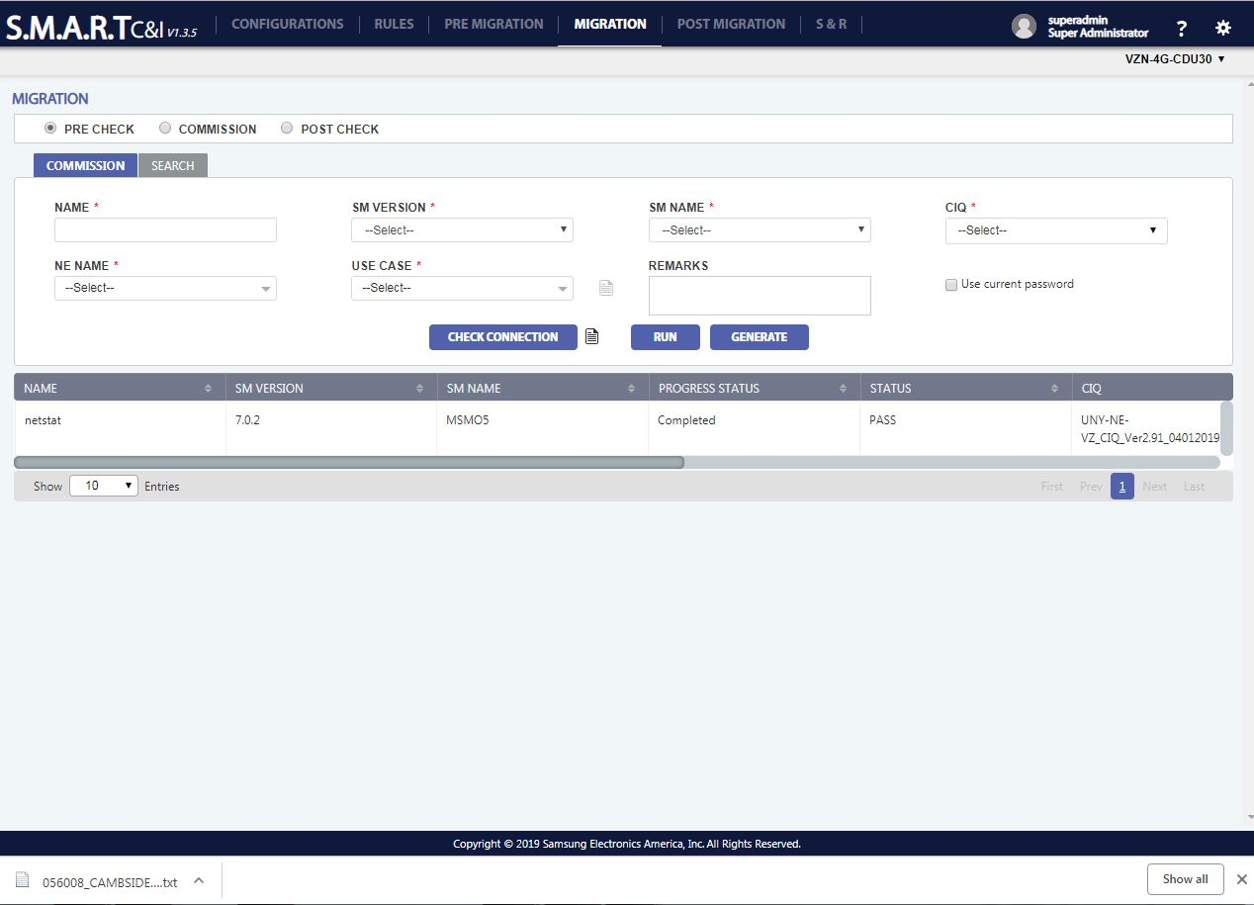

Figure 43: Migration: Download Log

User shall be able to see the output while run test is running on click of Running Log icon.

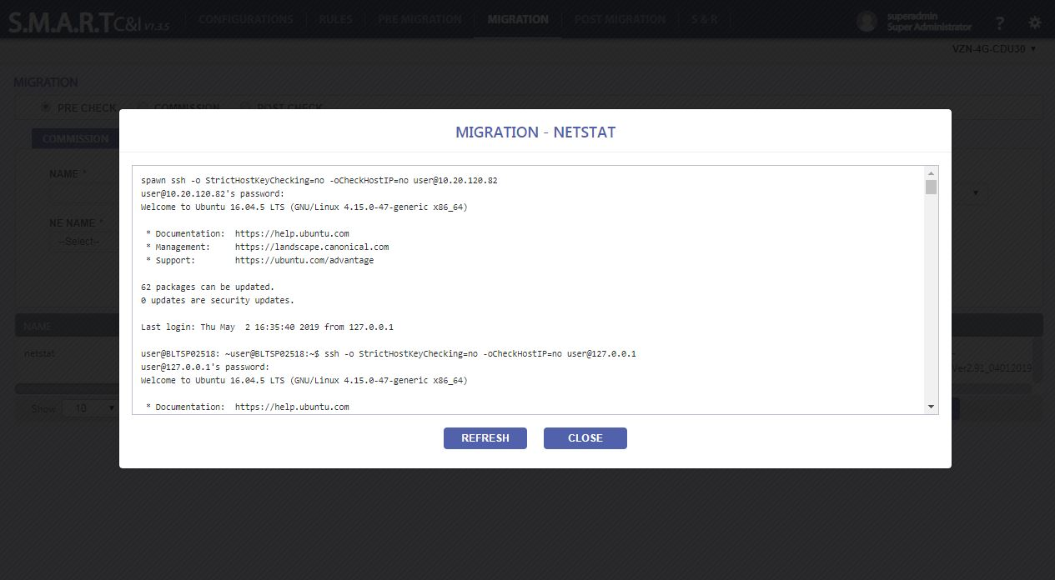

Figure 44: Migration: Running Log

User shall be able to see check list on click of check list icon.

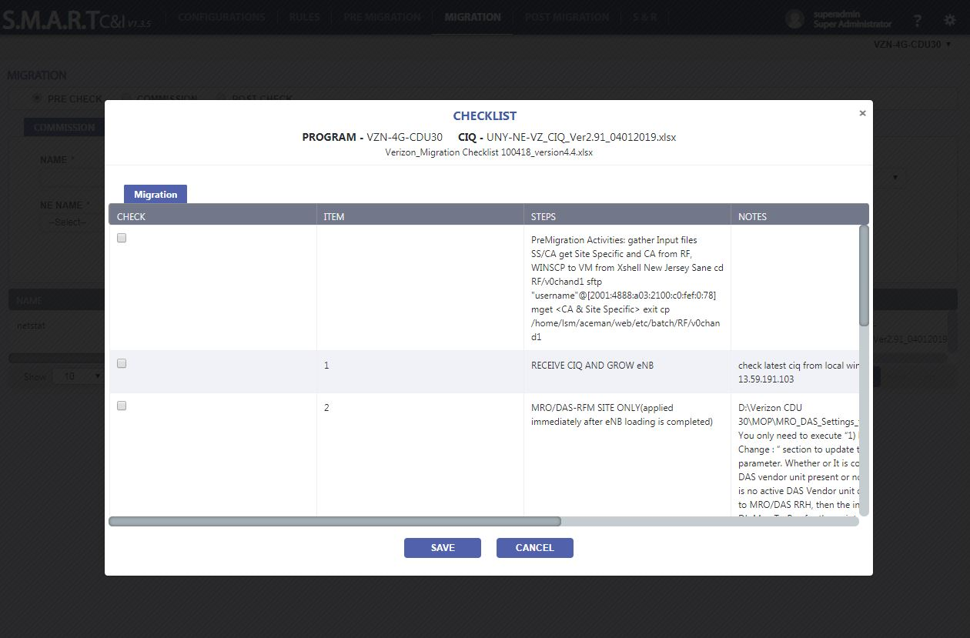

Figure 45: Migration: Check List

User shall be able to see report and script output details on click of view icon.

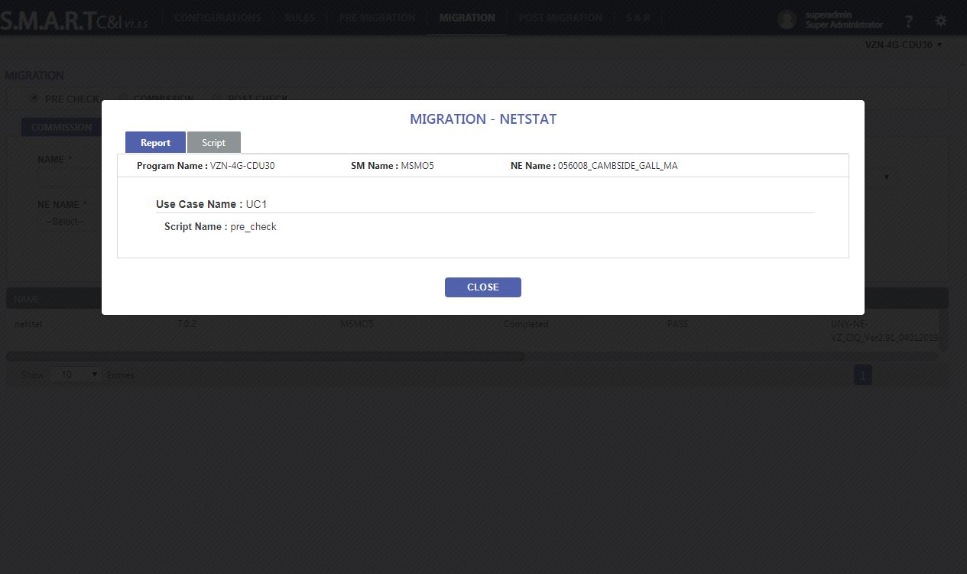

Figure 46: Migration: Check List

#### **DB Management**

This database is required to store the file rules, command rules, use cases and commissioning steps output generated by our commands and scripts. It is required to get result for multiple future queries.

## **Post Migration**

Post Migration is used health check the NE’s. For health check, we maybe executing set of command or set of scripts.

Migration is divided into three steps:

1. RAN ATP
2. Audit
3. Site Data
4. EOD Reports

### **Block diagram**

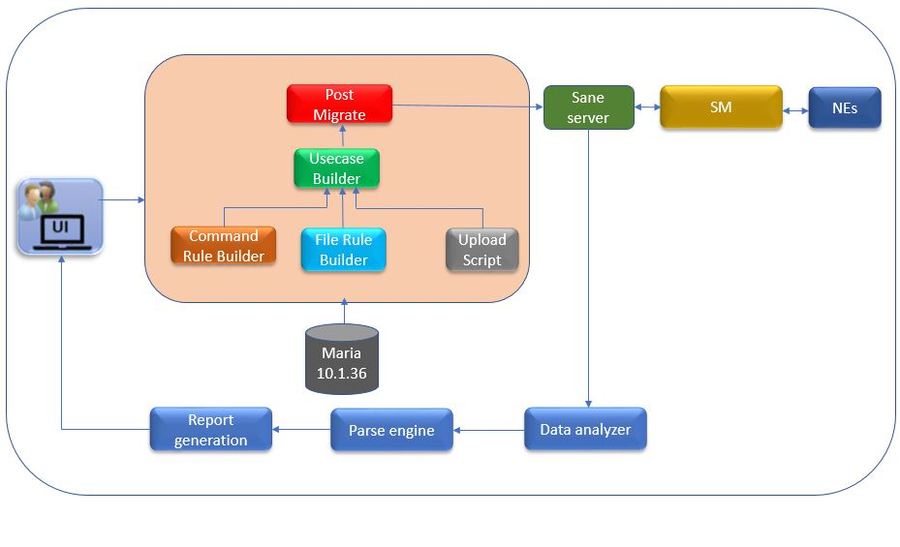

Figure 47: Block Diagram for Post Migration

#### **UI**

It is the user interface for the client.

#### **Command Store**

Scripts are uploaded by user

#### **Command Rule Builder**

The user can create rules for command execution.

#### **File Rule Builder**

The user can create rules for command execution.

#### **Use Case Builder**

Use Case Builder is created using command rule builder and file rule builder and scripts.

#### **RAN ATP**

User shall be able to create a RAN ATP based on SM Version, SM Name, CIQ, NE Name, Use Case and Run it.

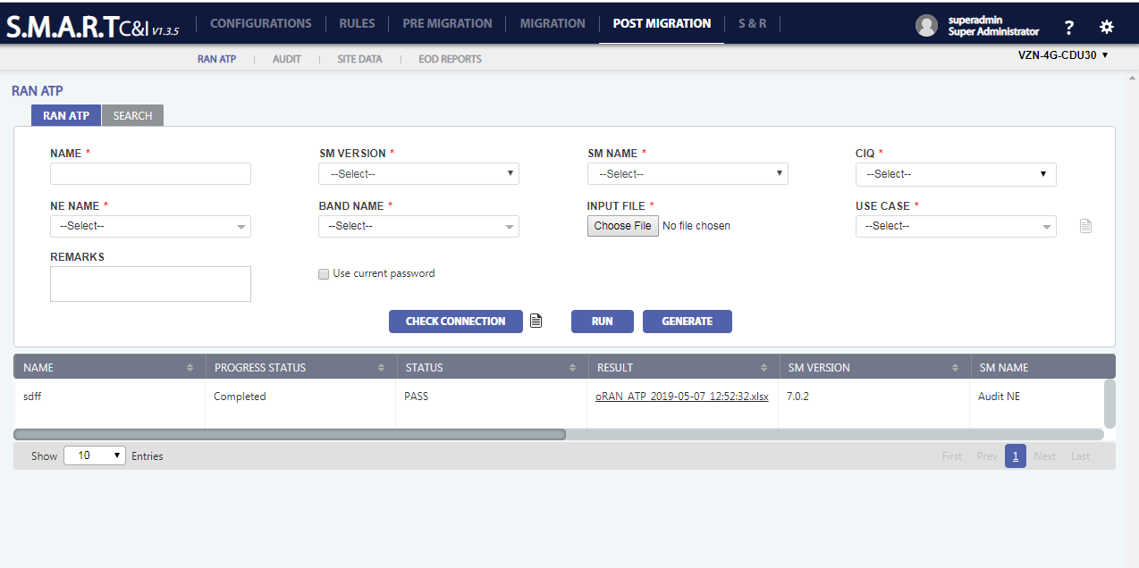

Figure 48: Post Migration: RAN ATP

User shall be able to download the output zip file on click of Download Logs icon.

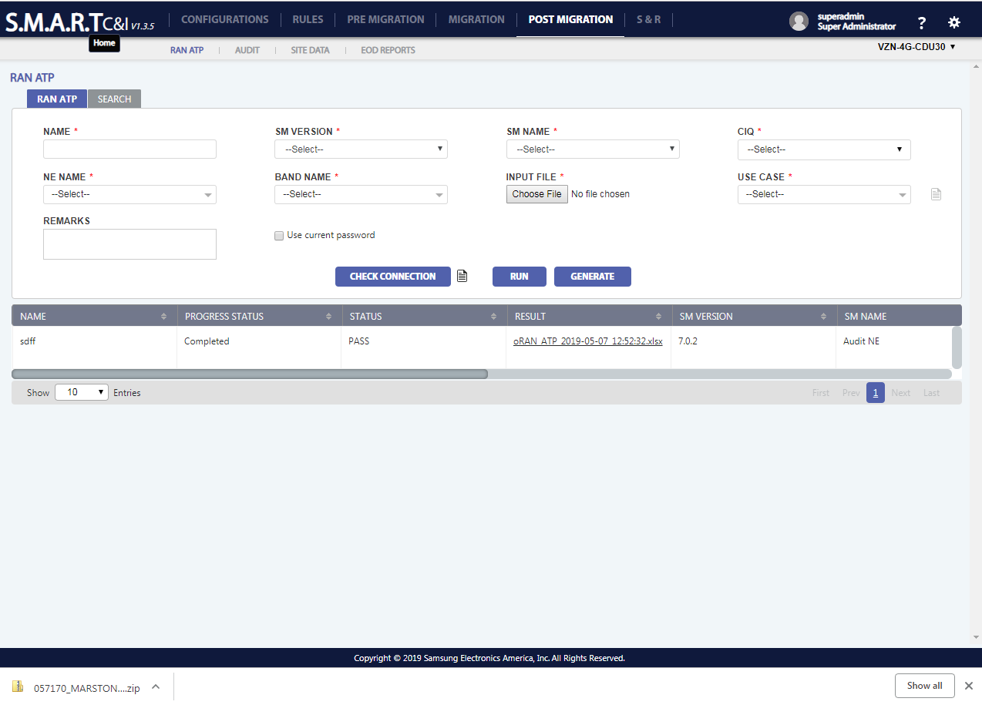

**Figure 49: Post Migration: Download Logs**

User shall be able to see the output while run test is running on click of Running Log icon.

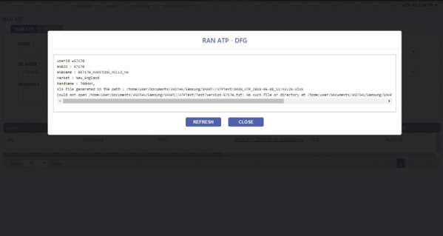

**Figure 50: Post Migration: Running Logs**

User shall be able to see check list details on click of Check List icon.

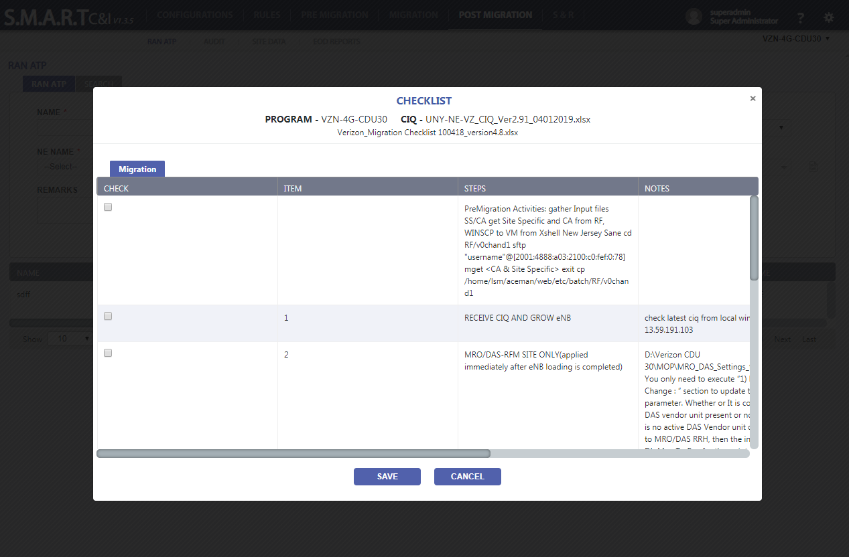

**Figure 51: Post Migration: Check List**

User shall be able to see report and script output details on click of view icon.

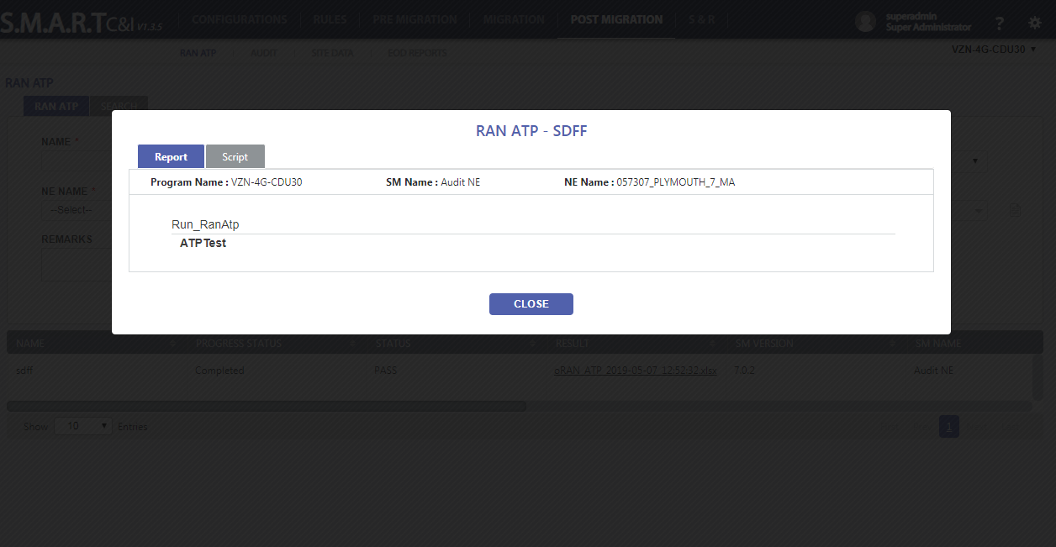

**Figure 52: Post Migration: Result View**

User shall be able to see the report in .xlsx format.

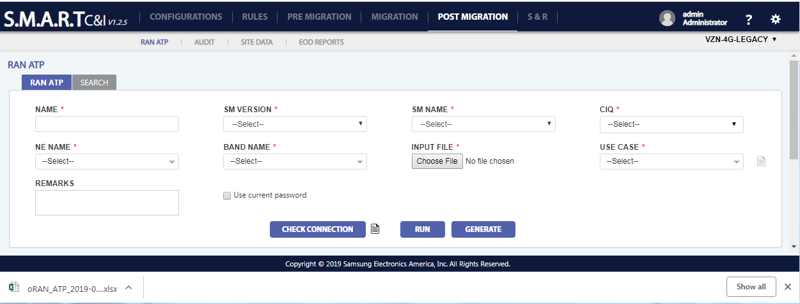

**Figure 53: Post Migration: Xlsx downloaded**

Sample xlsx report

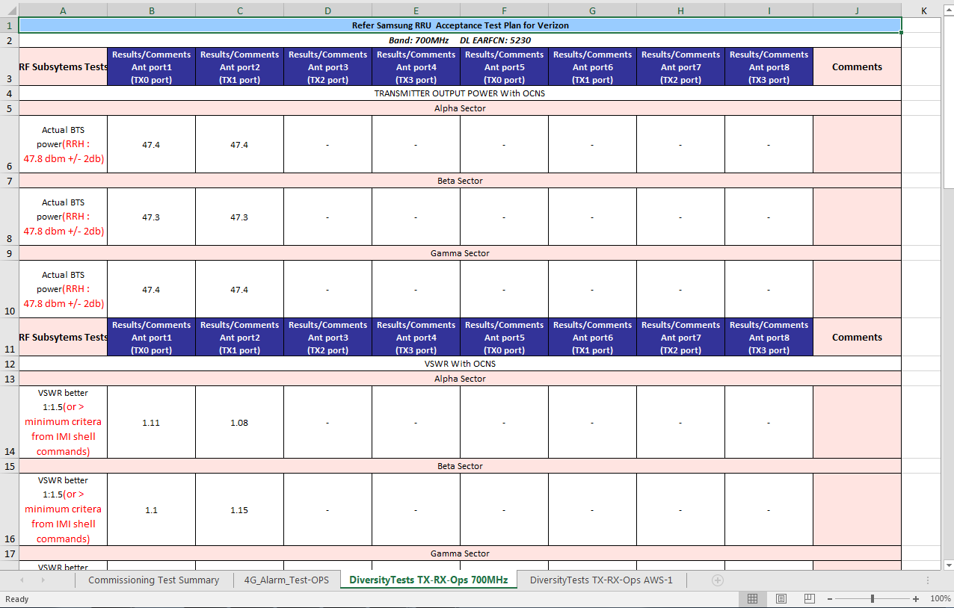

**Figure 54: Post Migration: Xlsx report**

#### **Audit**

User can audit all the events being carried out. Before auditing, user can test the connection by clicking on “Check Connection’

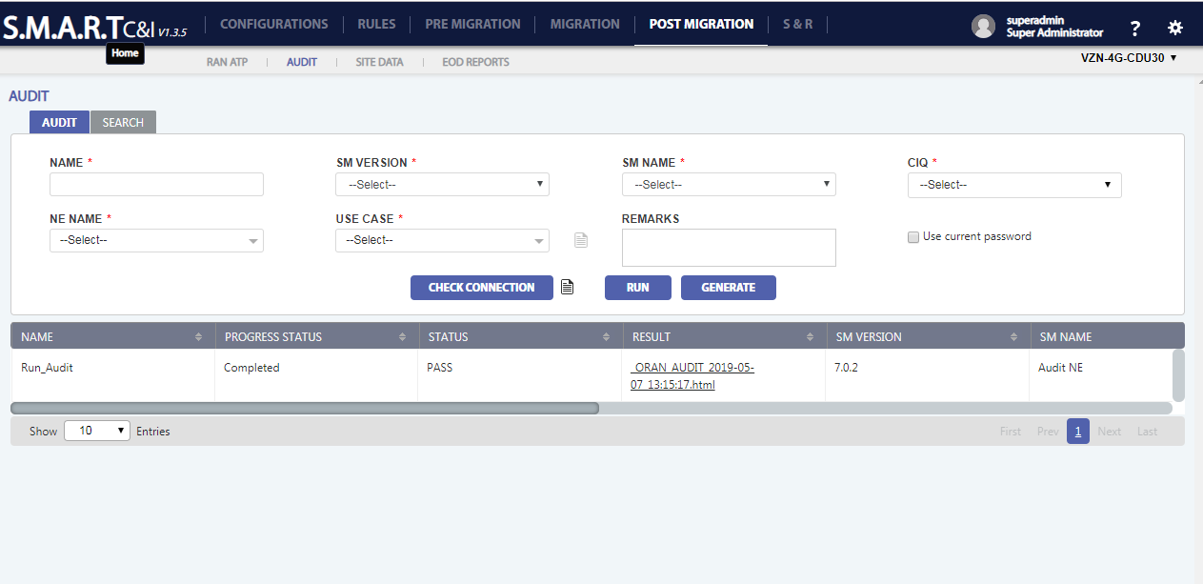

**Figure 55: Post Migration: Audit**

User shall be able to download the output zip file on click of Download Logs icon.

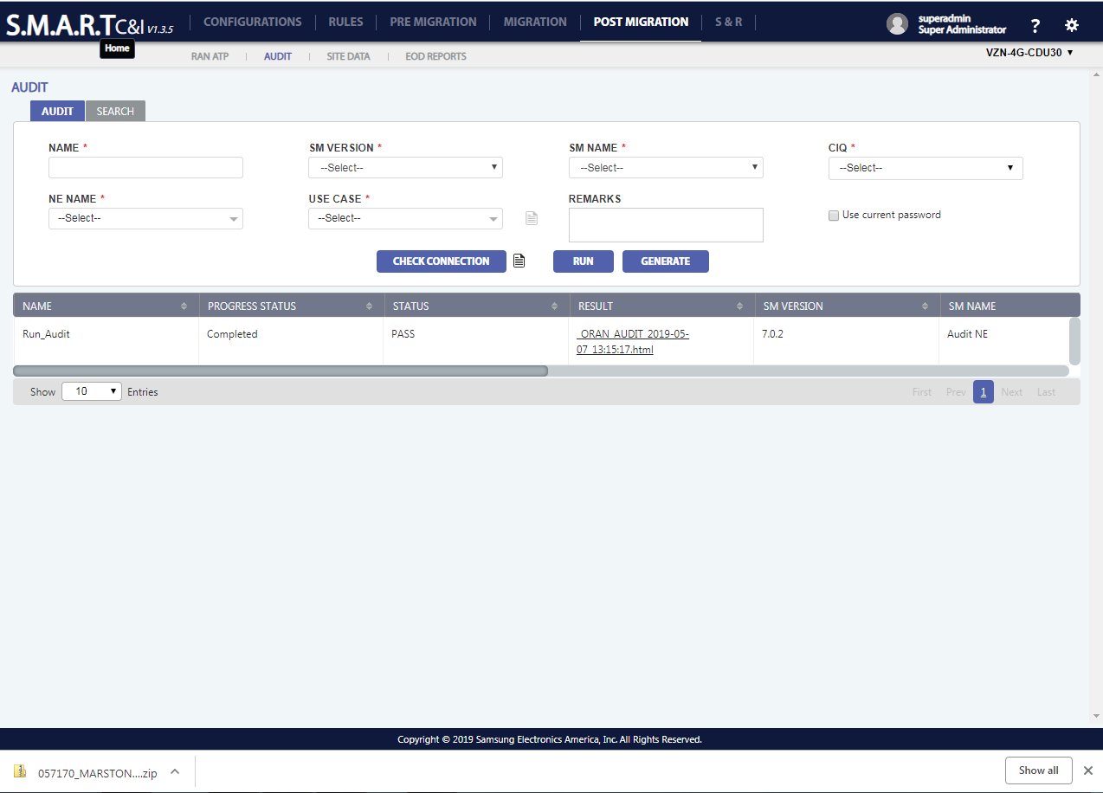

**Figure 56: Post Migration: Download logs**

User shall be able to see the output while run test is running on click of Running Log icon.

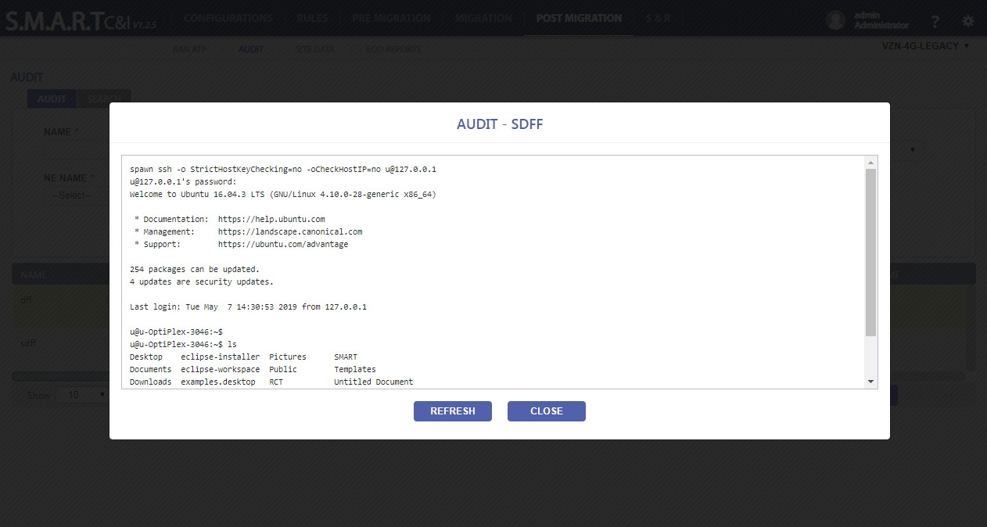

**Figure 57: Post Migration: Running Log**

User shall be able to see check list details on click of Check List icon.

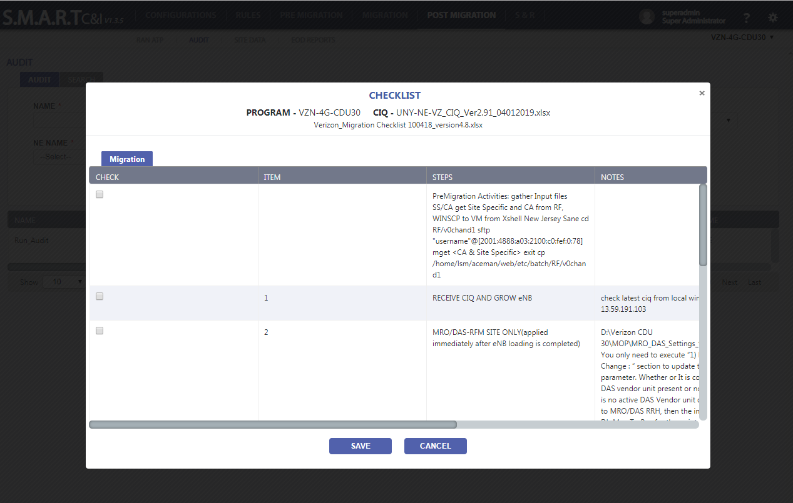

**Figure 58: Post Migration: Check List**

User shall be able to see report and script output details on click of view icon.

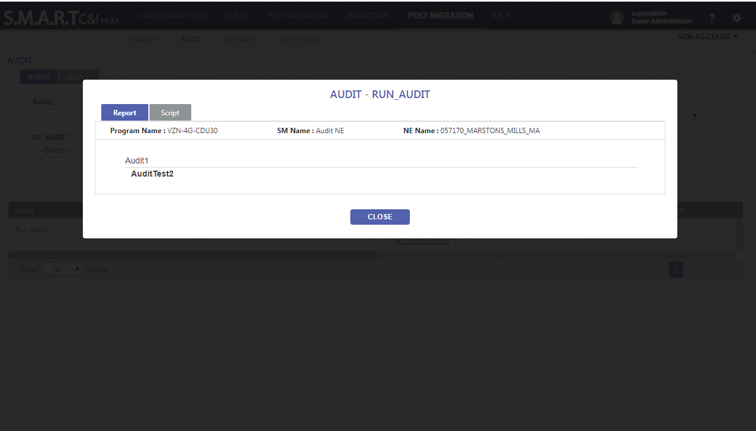

**Figure 59: Post Migration: Result View**

User shall be able to see html report on click of html file.

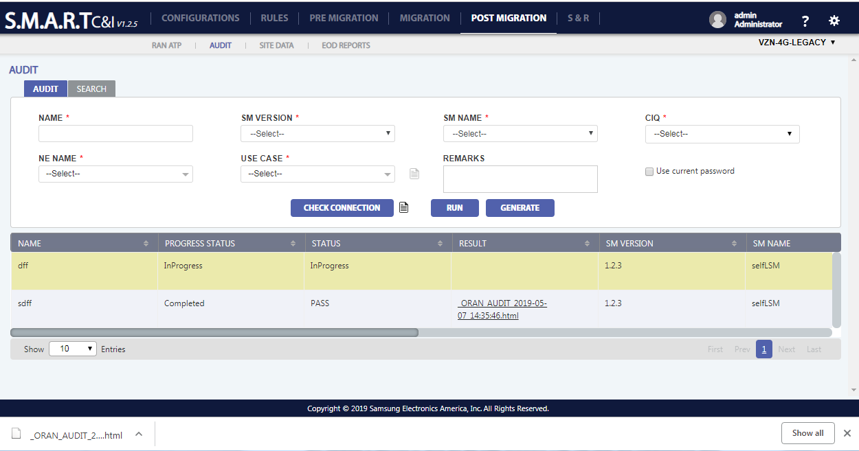

**Figure 60: Post Migration: html**

Sample Html output:

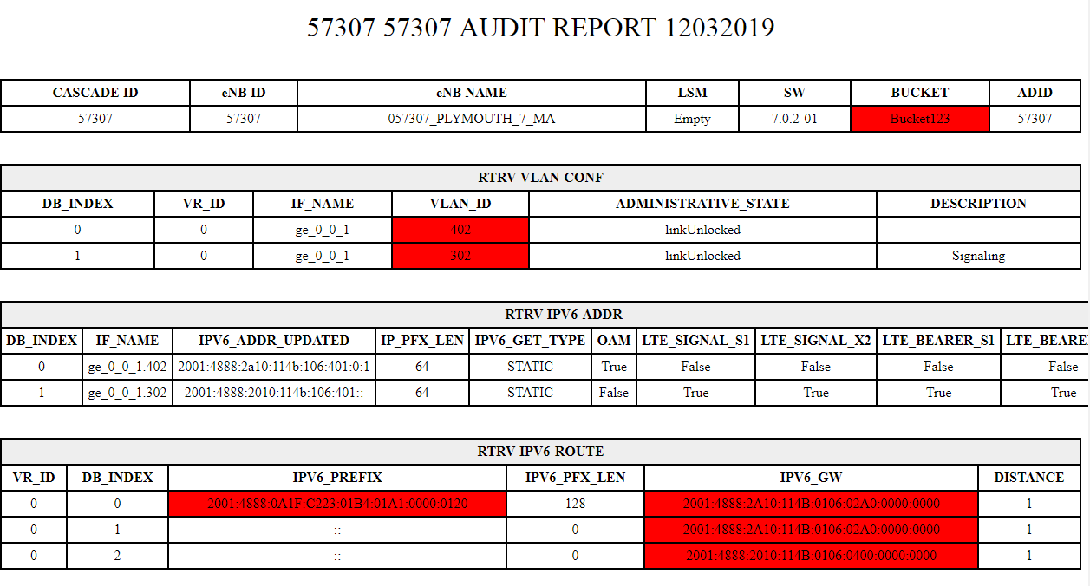

**Figure 61: Post Migration: html output**

#### **DB Management**

This database is required to store the file rules, command rules, use cases and commissioning steps output generated by our commands and scripts. It is required to get result for multiple future queries

#### **Site Data**

Site data supports the user to pack the entire details of a specific eNB from input to output and allows to download the pack to a local machine or can send to multiple email id’s same time.

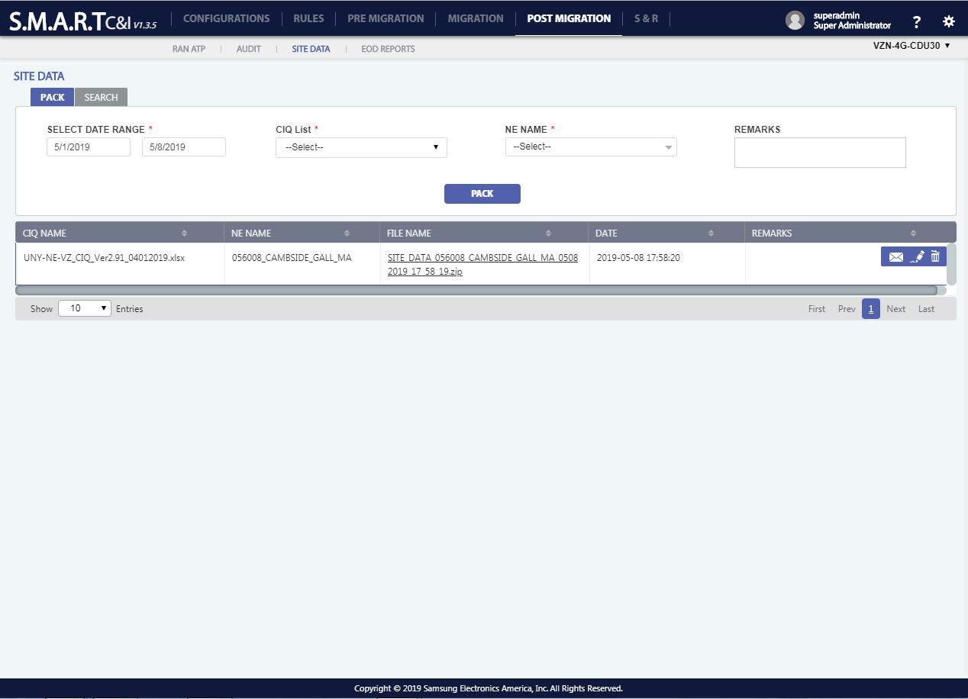

Figure 62: Post Migration - Site Data

1. **To Search** a site data record, click on search Button () placed on top of the data table and enter the required fields to search.
2. **To Mail a** file, click on the mail icon () appearing when roll over on a site details record.
3. **To Edit** file details, click on the edit icon () appearing when roll over on a site details record. All fields are non - editable except remarks.
4. **To Delete** record, click on the delete icon () appearing, when roll over on a user detail record. A confirmation popup with “YES/NO” options appears on click of delete icon. “YES” will delete the record and “NO” will be redirected to the previous screen.
5. **To pack** the details, click on the pack icon () appearing above the table data to pack the data.

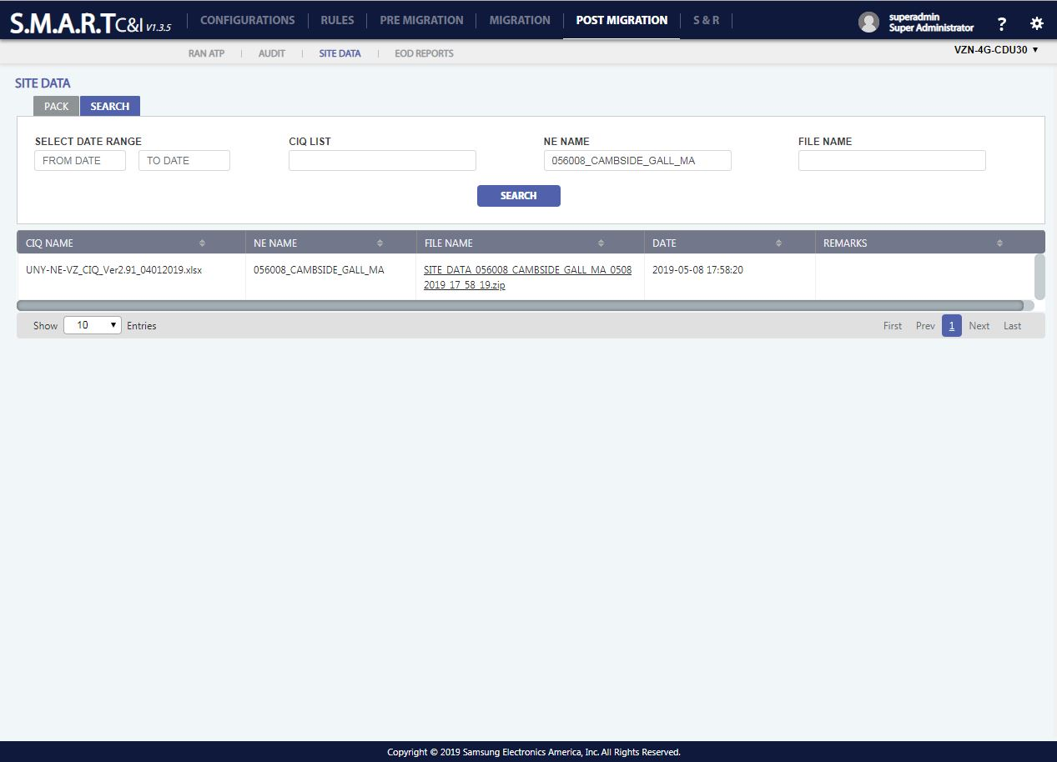

Figure 63: Post Migration - Site Data - Search

#### **EOD Reports**

User can generate reports based on events.

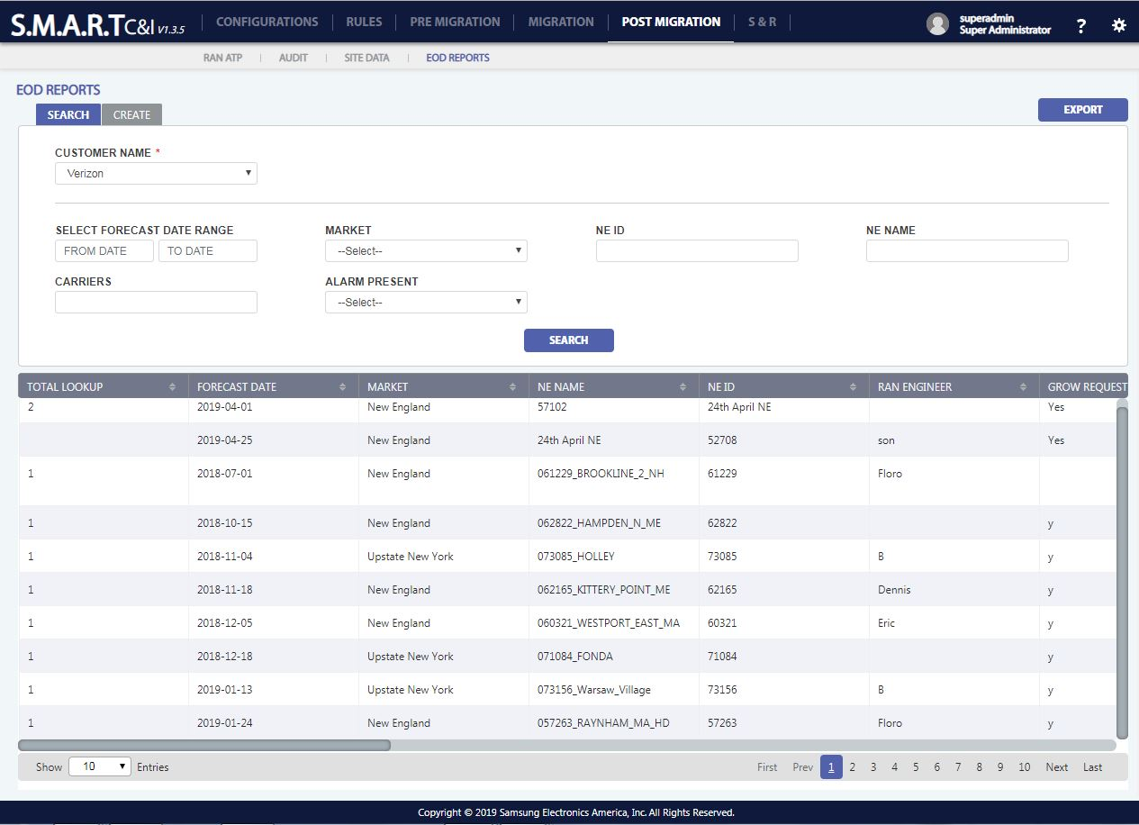

Figure 64: Post Migration: EOD Reports

## **S & R**

S & R Page consists of:

1. Scheduling
2. Overall Reports
3. Reports

### **Scheduling:**

The entire Commissioning process can be scheduled using the Scheduler.

User needs to provide the Forecast Date, Comp date, Market Area, eNB ID, NE Name, Grow Request and so on.

The input details can be imported using the ‘IMPORT’ functionality and can also exported to a excel file using the ‘EXPORT’ Functionality.

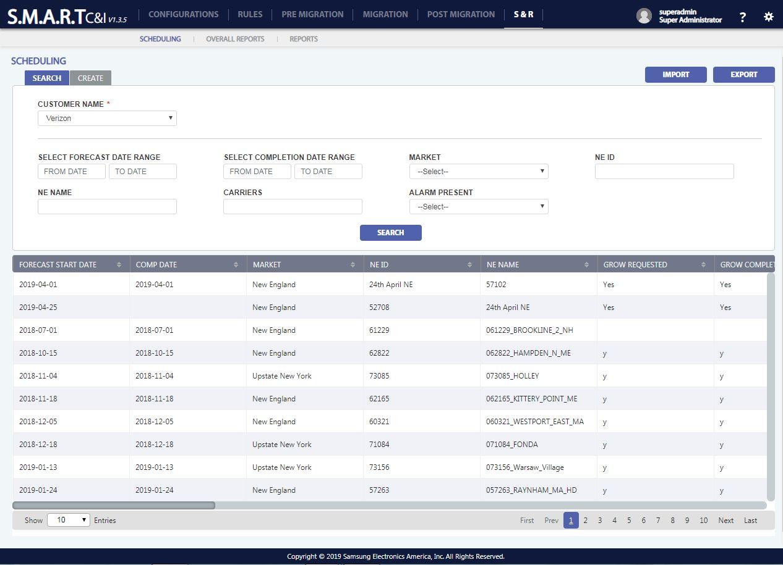

Figure 65: S & R: Scheduling – Verizon

1. **To search** a Scheduling record, click on search Button () placed on top of the data table and enter the required fields to search.
2. **To create** a new Scheduling record, Click on Create New Button () placed on top left position of the data table and enter the mandatory fields which are Forecast Data, Comp Date, Market, NE ID, NE Name.
3. **To edit a** Scheduling record, click on the edit icon () appearing when roll over on details record. All fields are editable.
4. **To delete** a Scheduling record, click on the delete icon () appearing, when roll over on a scheduling detail record. A confirmation popup with “YES/NO” options appears on click of delete icon. “YES” will delete the record and “NO” will be redirected to the previous screen.
5. **To export** existing Scheduling Details, click on export icon () placed on top right position of the data table.
6. **To import** Scheduling Details to database, click on import icon () placed on top right position of the data table.

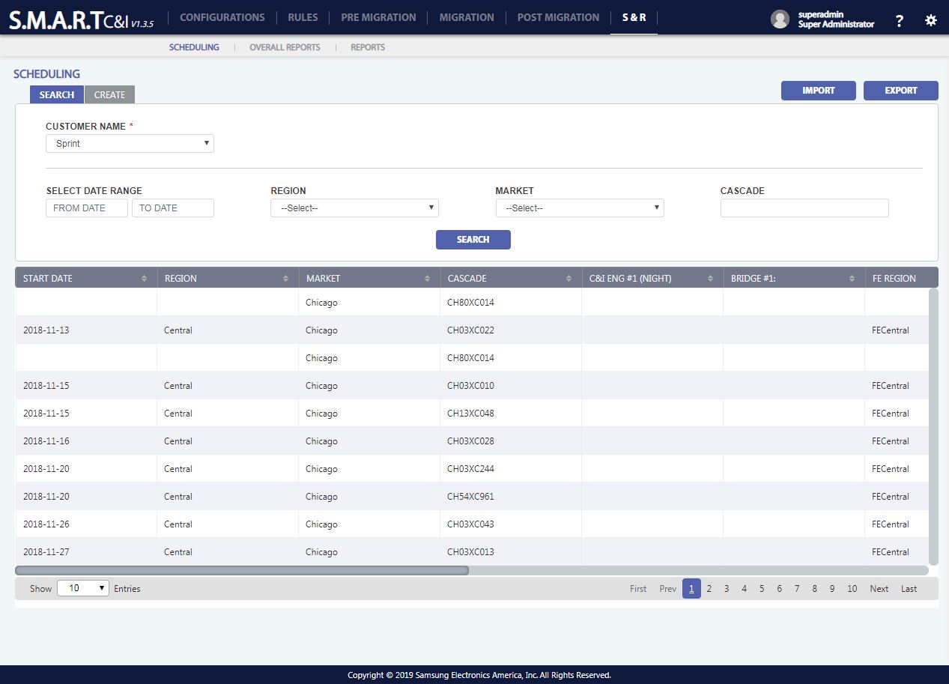

Figure 66: S & R: Scheduling – Sprint

### **Overall Reports**

All reports pertaining to the commission of a specific NE can be generated/ displayed using this section.

User can manually edit the status of event. The status of commissioning will be displayed against each eNB.

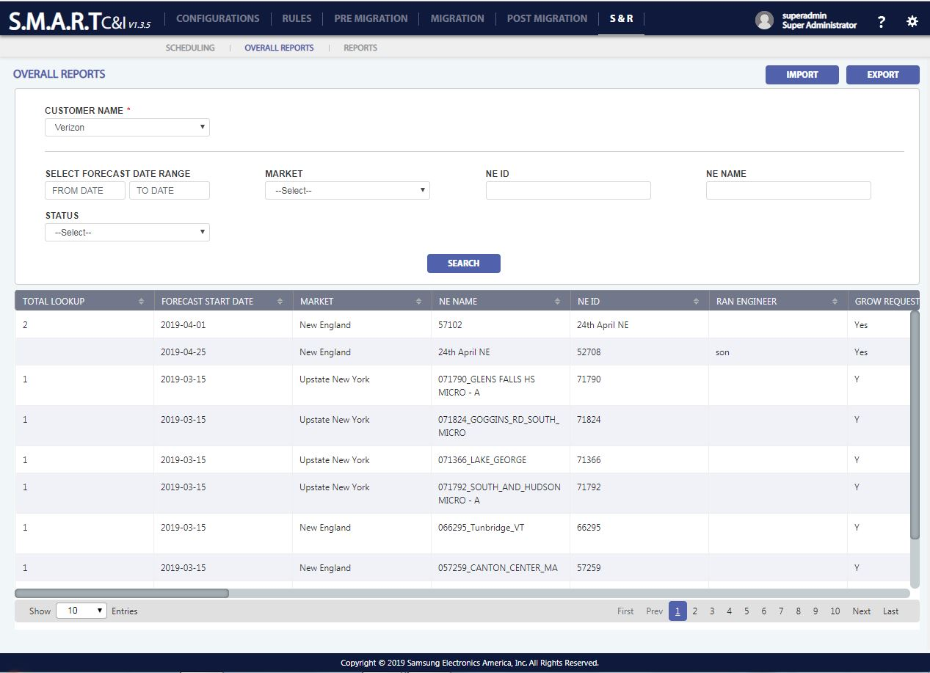

Figure 67: S & R: Overall Reports – Verizon

1. **To search** an Overall Details record, click on search Button () placed on top of the data table and enter the required fields to search.
2. **To create** a new Overall Details record, Click on Create New Button () placed on top left position of the data table and enter the mandatory fields which are Forecast Data, Comp Date, Market, NE ID, NE Name.
3. **To edit an** Overall Details record, click on the edit icon () appearing when roll over on details record. All fields are editable.
4. **To delete** an Overall Details record, click on the delete icon () appearing, when roll over on a scheduling detail record. A confirmation popup with “YES/NO” options appears on click of delete icon. “YES” will delete the record and “NO” will be redirected to the previous screen.
5. **To export** existing Overall Details, click on export icon () placed on top right position of the data table.
6. **To import** Overall Details to database, click on import icon () placed on top right position of the data table.

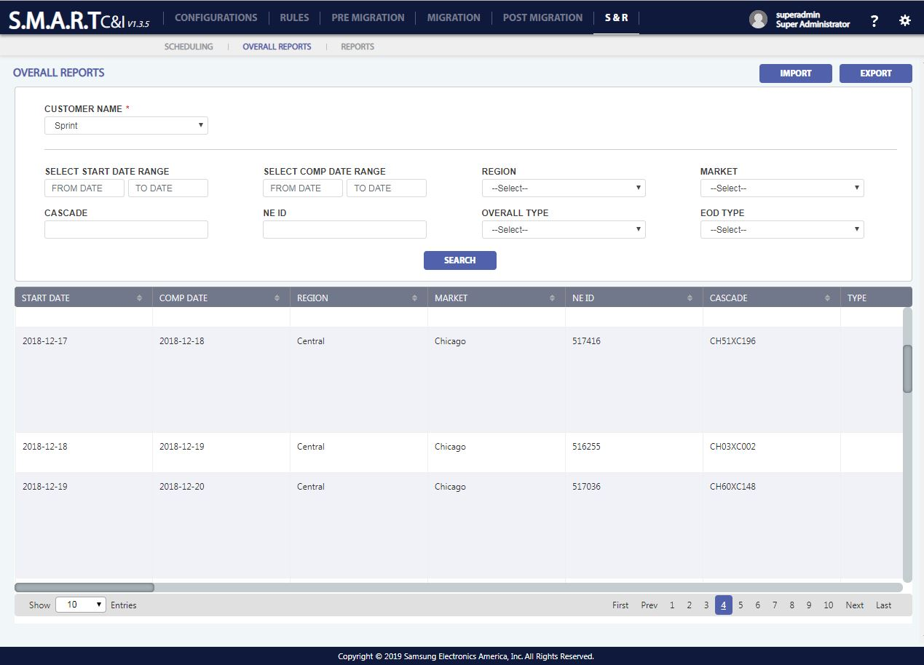

Figure 68: S & R: Overall Reports - Sprint

### **Reports**

Reports display the status of the overall reports in 3 options

1. Daily
2. Weekly
3. Periodic

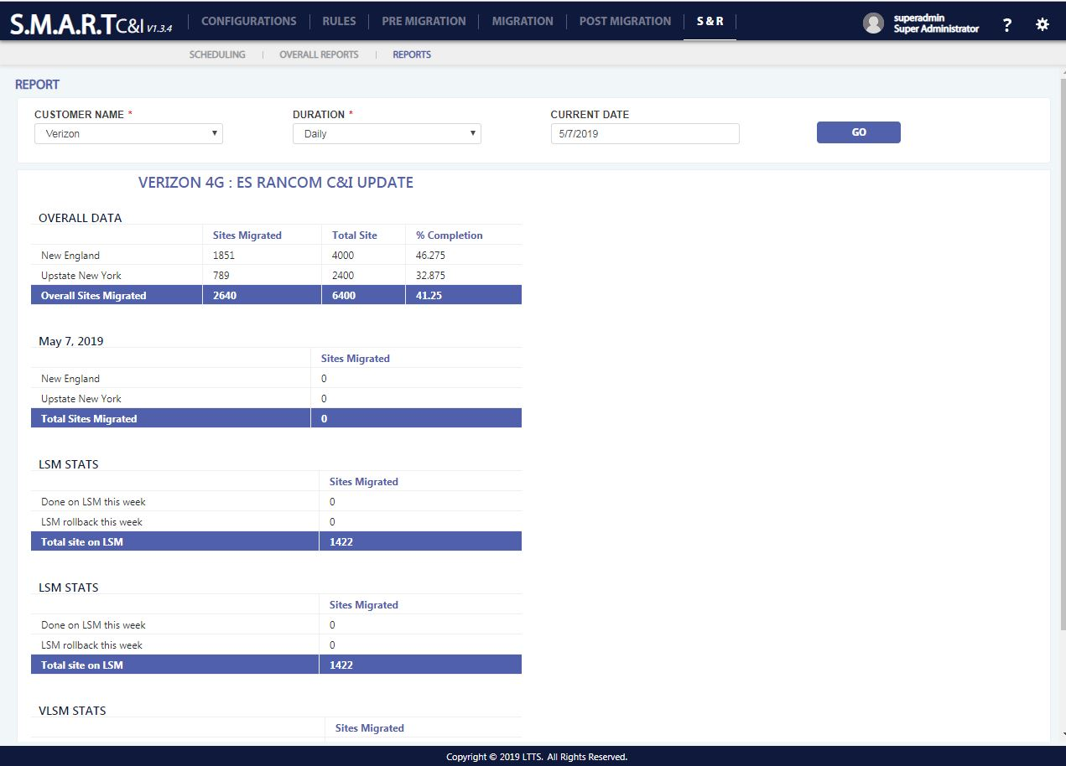Reports page displays the overall reports data in daily basis

Figure 69: S & R: Reports - Daily

Reports page displays the overall reports data in Weekly basis

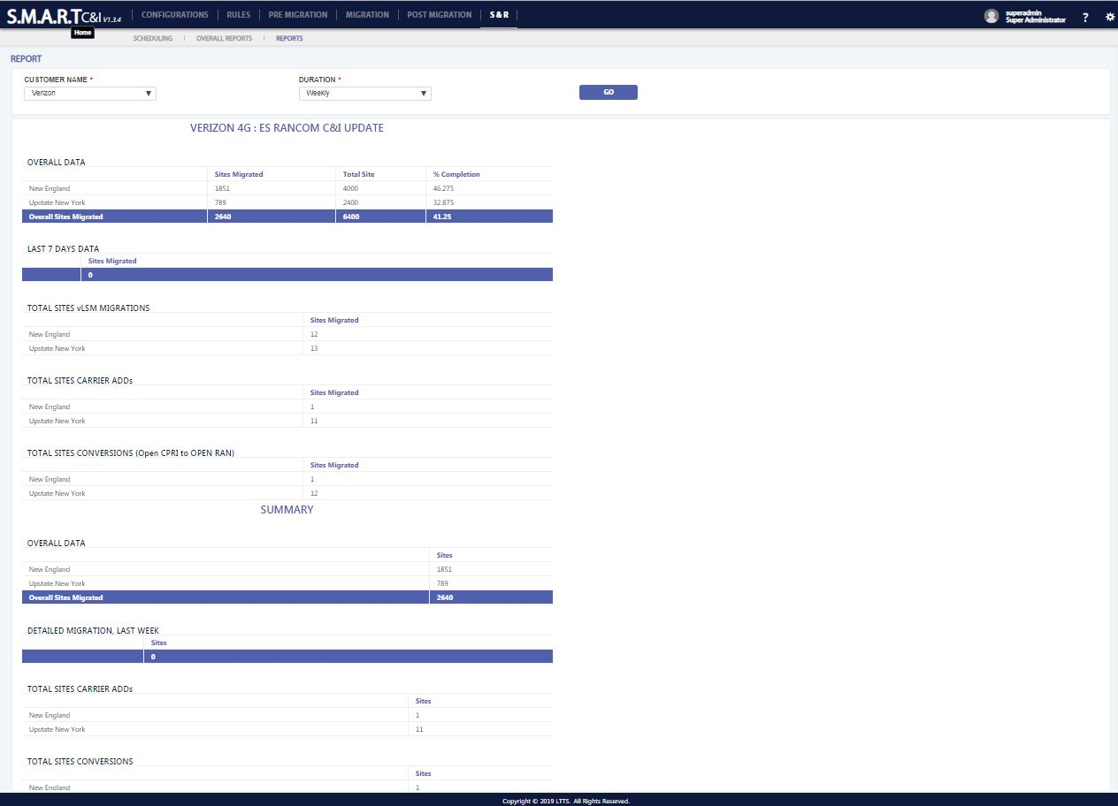

Figure 70: S & R: Reports - Weekly

Reports page displays the overall reports data in periodic basis

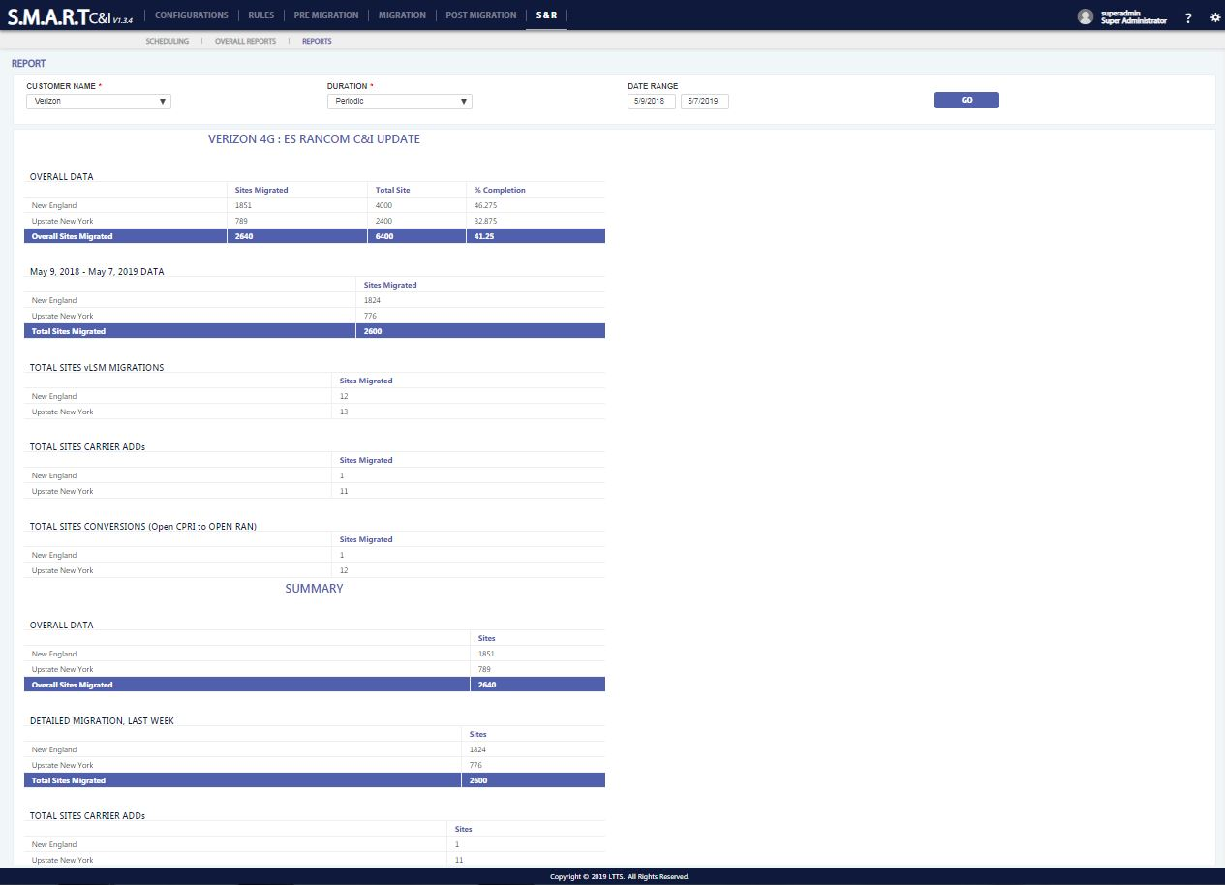

Figure 71: S & R: Reports - Periodic